1) Setup jenkins CICD pipeline using freestyle job using Docker containers using below code.
https://github.com/betawins/hiring-app.git
Stages:
1) Git Clone
2) Sonarqube Integration
3) Maven Compilation
4) Nexus Artifactory
5) Slack Notification
6) Deploy on tomcat
Gitclone & sonarqube
Installed jenkins in jenkins-ec2 take t2.large+20gb
Created sonarqube-ec2 take t2.large and installed docker and pull image of sonarqube.
yum -y install docker
systemctl start docker
docker pull sonarqube (only download image.)
docker run -d --name sonarqube -p 9000:9000 sonarqube:lts
(download (if needed) + create + start container.)
Docker ps
In jenkins master>available plugins> install sonarqube-scanner plugin
Go to Manage Jenkins → System.
Scroll to SonarQube servers section.
Add:
- Name → SonarQube
- Server URL → your SonarQube URL (example: http://<sonarqube-server-ip>:9000)
- Authentication Token → generate one in SonarQube (My Account → Security → Tokens).
- Now in jenkins home page, create a job hiring-app and enter the analysis properties
- https://github.com/betawins/hiring-app.git
- The repo is in main branch same need to configure in job also.
Maven installations
cd /opt/
wget https://dlcdn.apache.org/maven/maven-3/3.9.11/binaries/apache-maven-3.9.11-bin.tar.gz
tar xvf apache-maven-3.9.11-bin.tar.gz
mv apache-maven-3.9.11 maven (optional)
cd maven/ > pwd path(/opt/maven/bin) fixing for Jenkins to locate the job
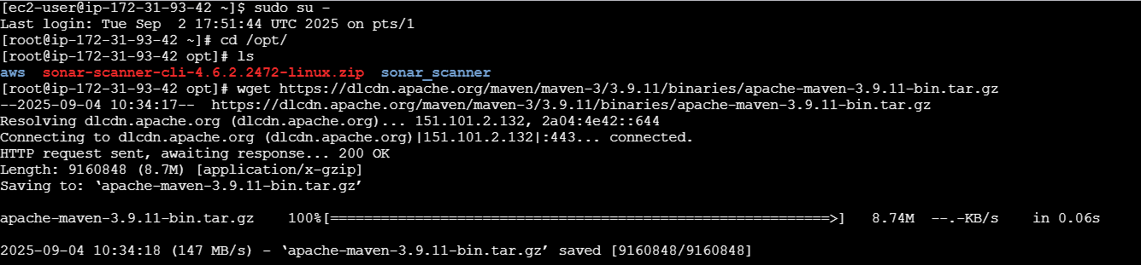
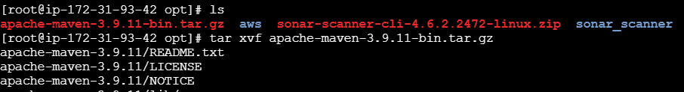
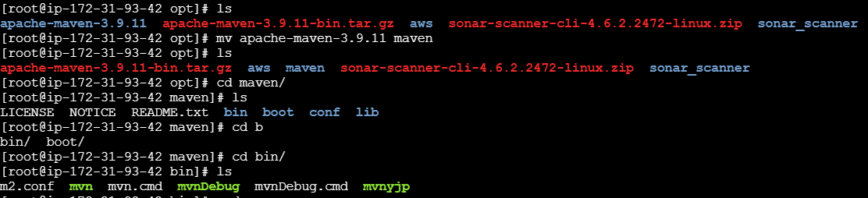
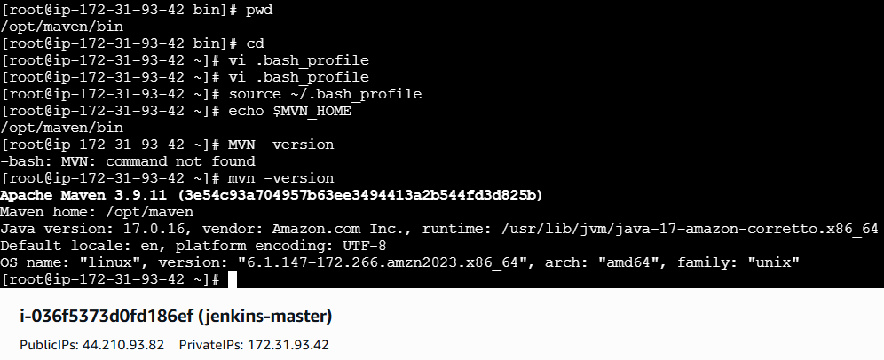
vi .bash_profile
MVN_HOME=/opt/maven/bin
PATH=$PATH:$HOME/bin:$MVN_HOME
export PATH
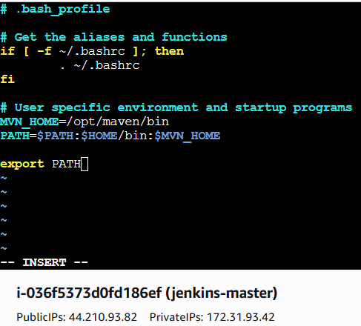
source ~/.bash_profile > To restart edited file.
echo $MVN_HOME > To check path available at home.
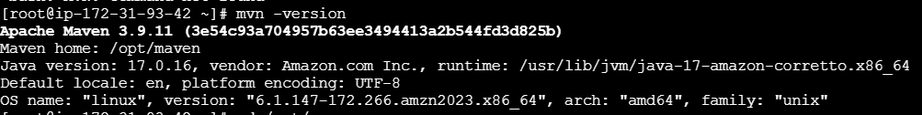
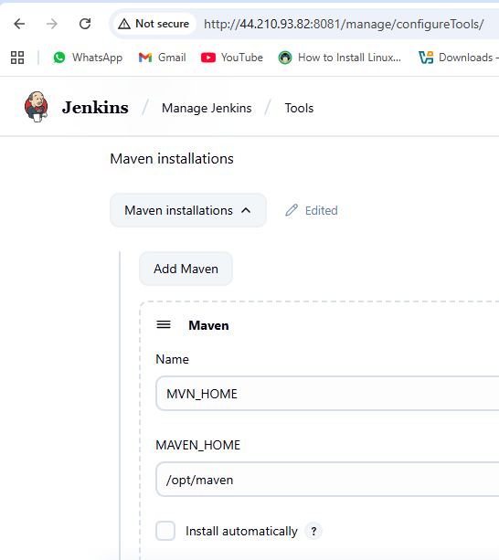
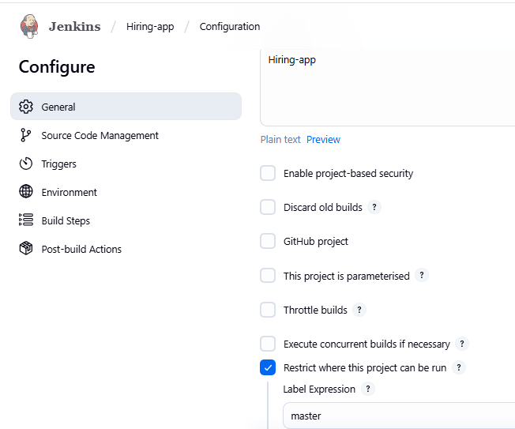
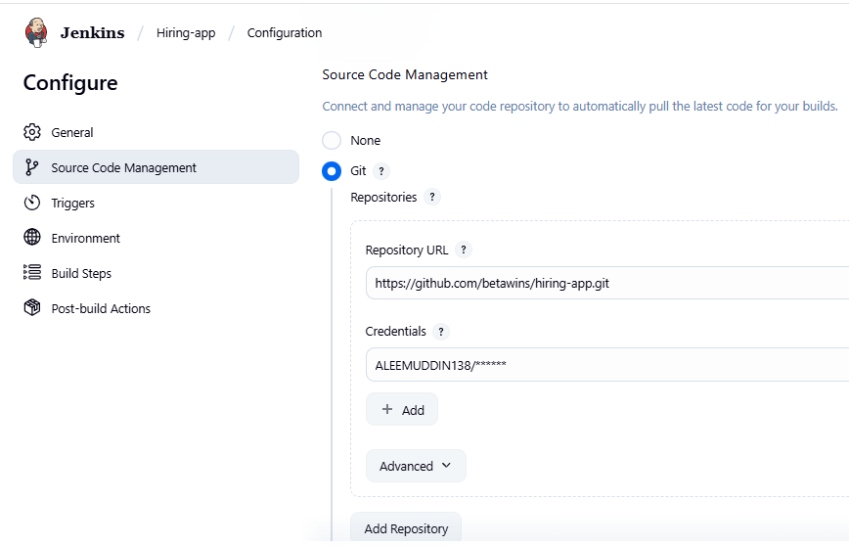
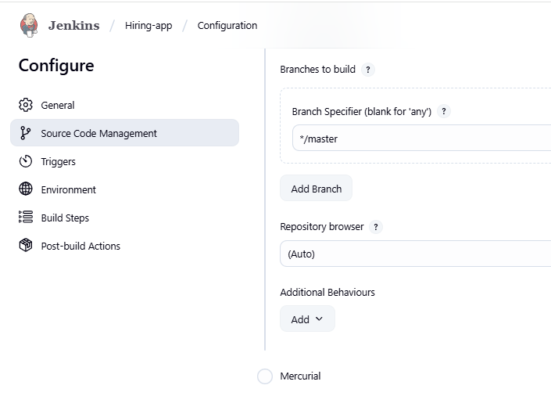
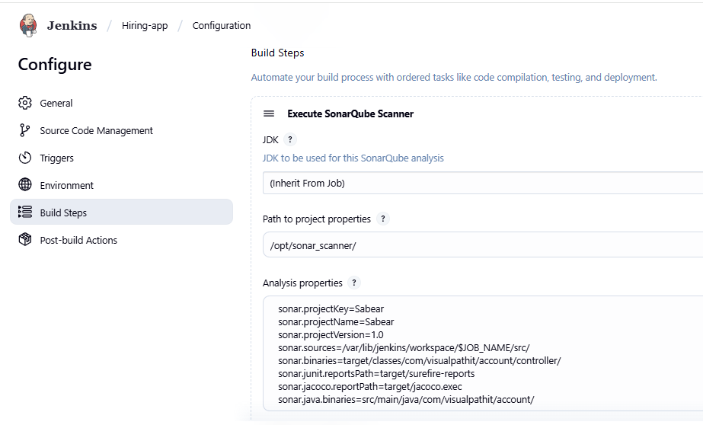
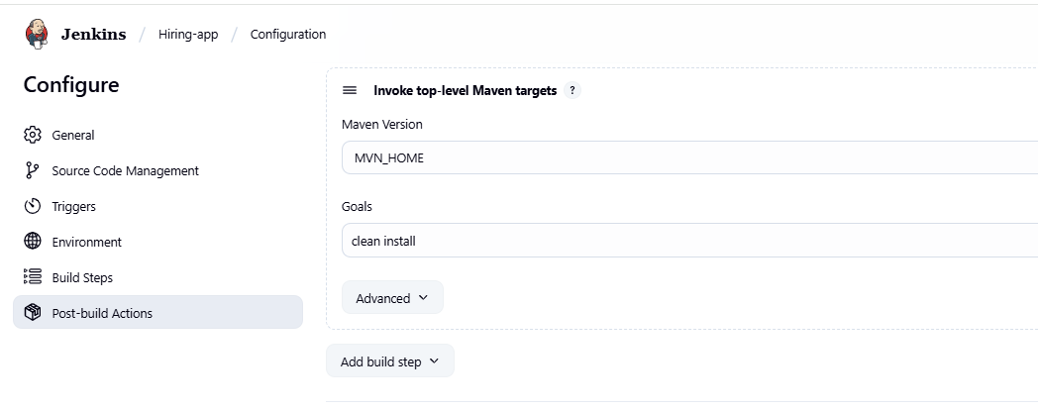
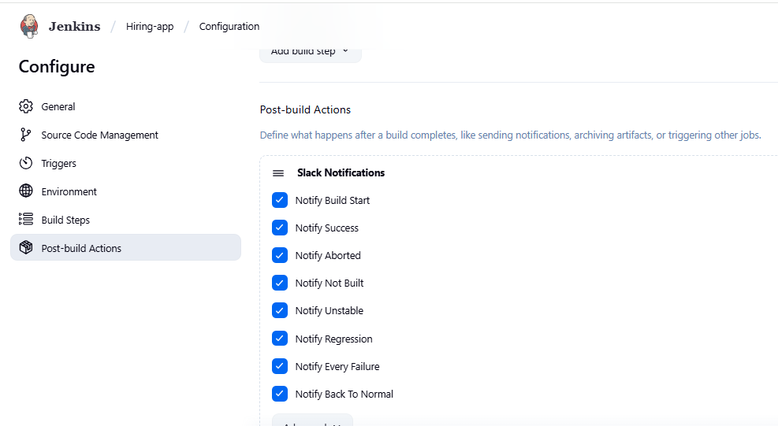
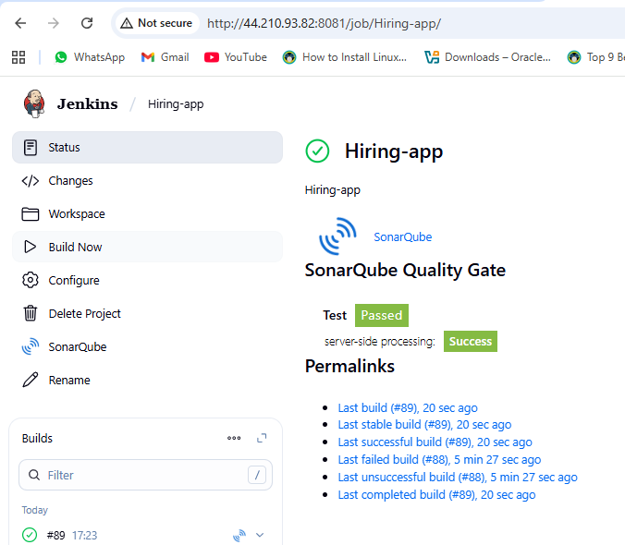

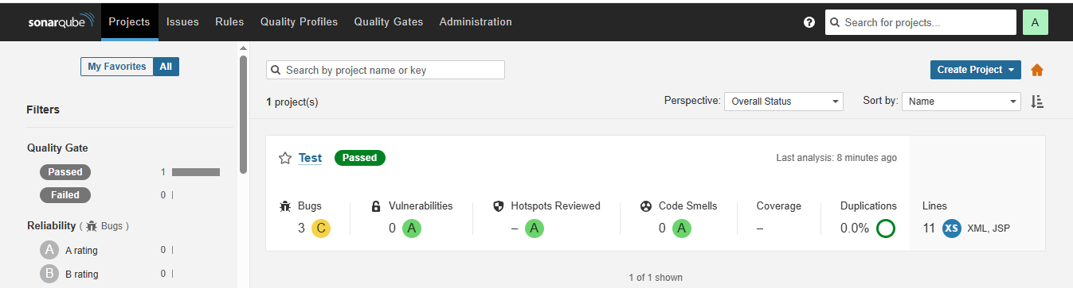
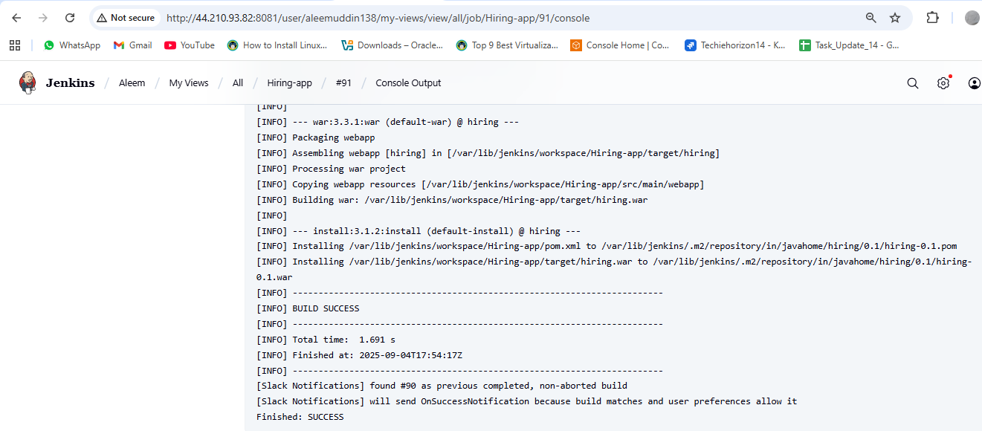
One package is created after build the job, we can see the .war file in the below picture.
If package are not created or fail during build then we need to go local machine.
Cd /var/lib/jenkins/workspace/Hiring-app/ > ll
mvn clean install > manual can go by local machine to create package .war file.

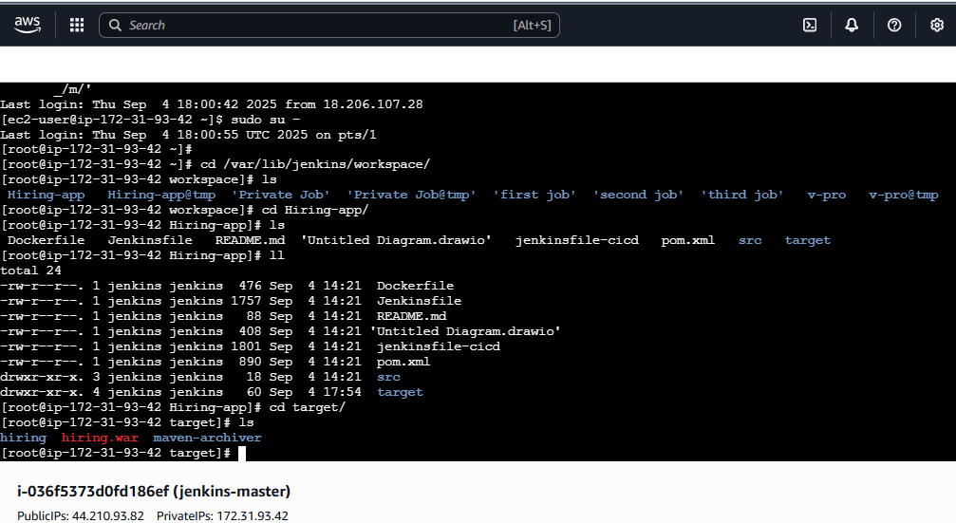
Dependencies related to Appication has been downloadad and save into directory .m2 Maven.
Maven having 3 types of repositories local, central & remote.
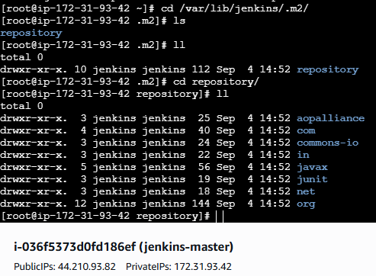
Create one nexus-ec2 with t2-large configuration
yum –y install java-1.8*
cd /opt
wget https://sonatype-download.global.ssl.fastly.net/nexus/3/nexus-3.0.2-02-unix.tar.gz
tar -zxvf nexus-3.0.2-02-unix.tar.gz
mv /opt/nexus-3.0.2-02 /opt/nexus
vi /opt/nexus/bin/nexus.rc
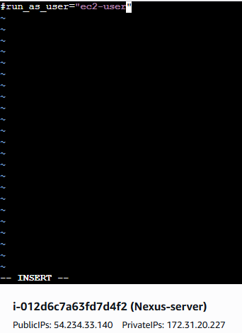
cd /opt/nexus/bin/
sudo chown -R ec2-user:ec2-user nexus
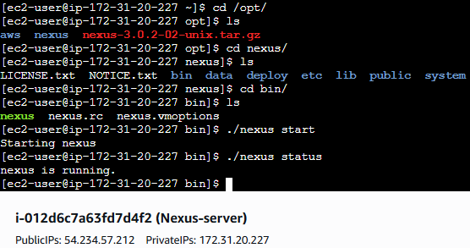
Go to browser http://< public I.P >:8081 Default port number
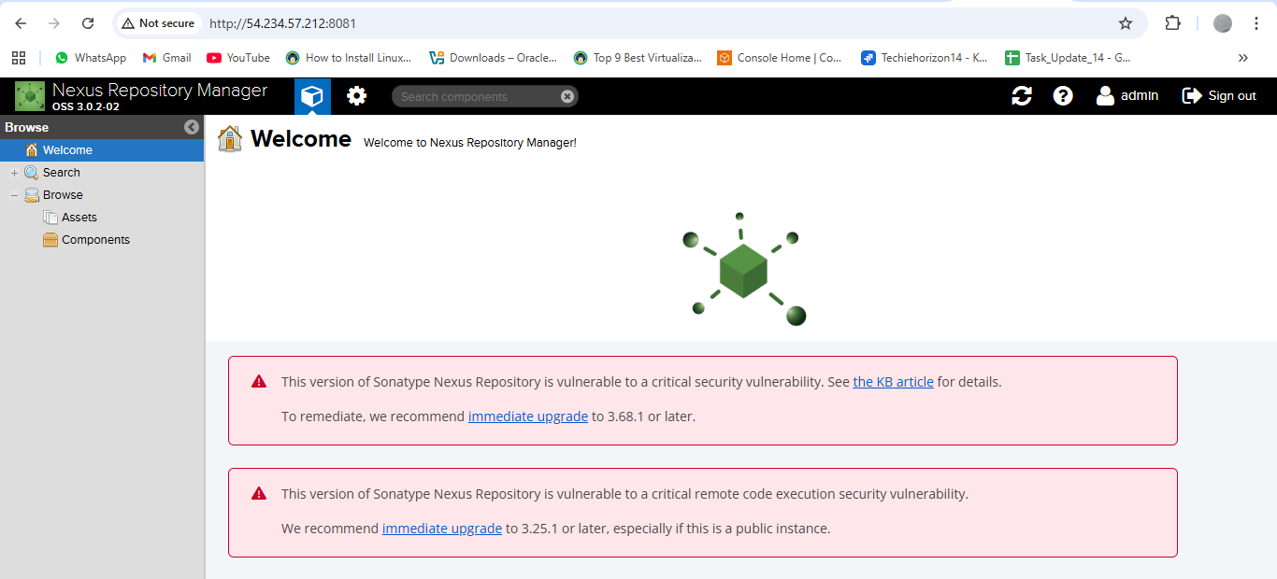

Go to Jenkins job configurations and fill the required information’s in Nexus artefact uploader.
Then go to jenkins and install plugins (Nexus artifact loader)
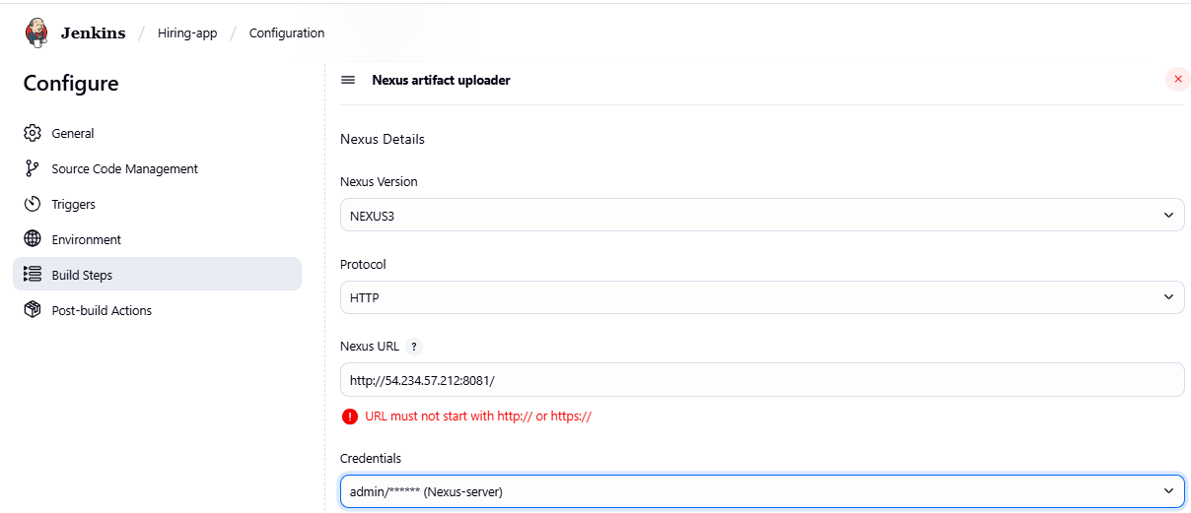
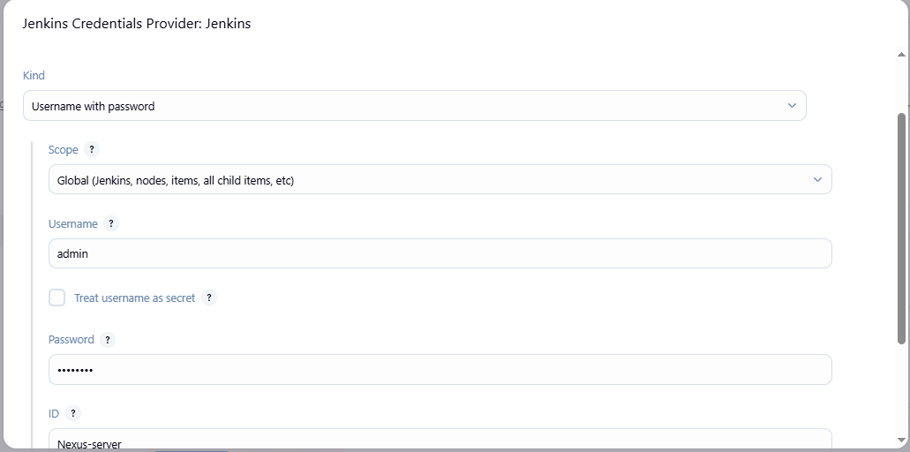
Go to github hiring-app repository>pom.xml>copy group id & version.
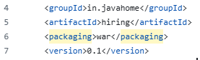
Paste it here
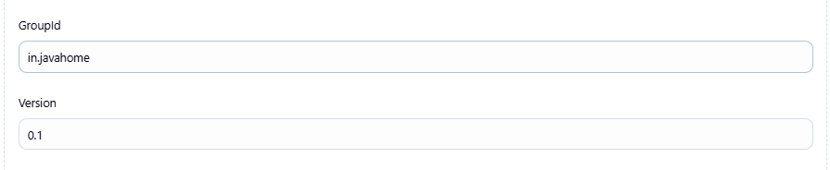
Go to nexus page > setting > Repositories > Select recipe > Create repository:Maven2(hosted)
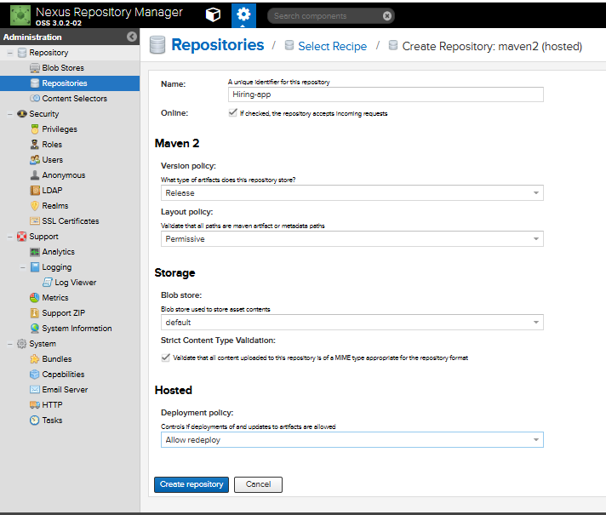
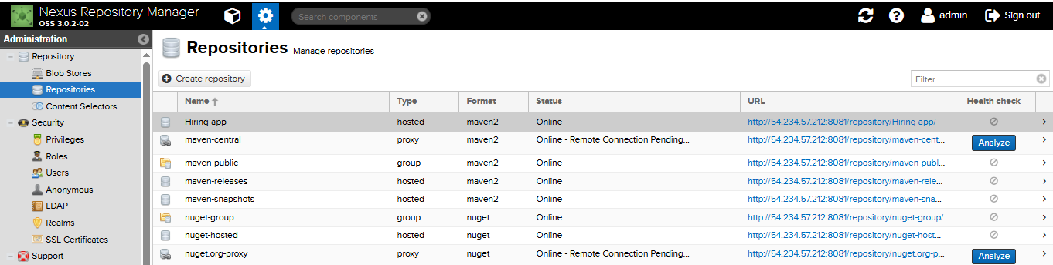

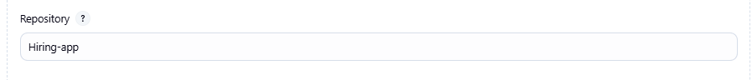
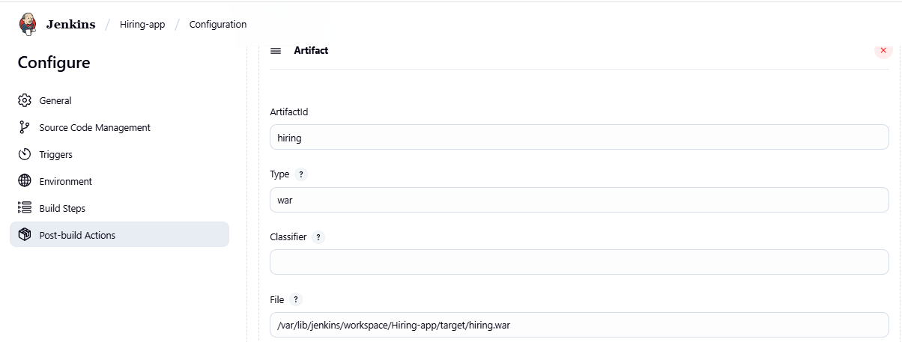
Make the changes save and Build the Job to check the nexus artefact .war project successfully completed.
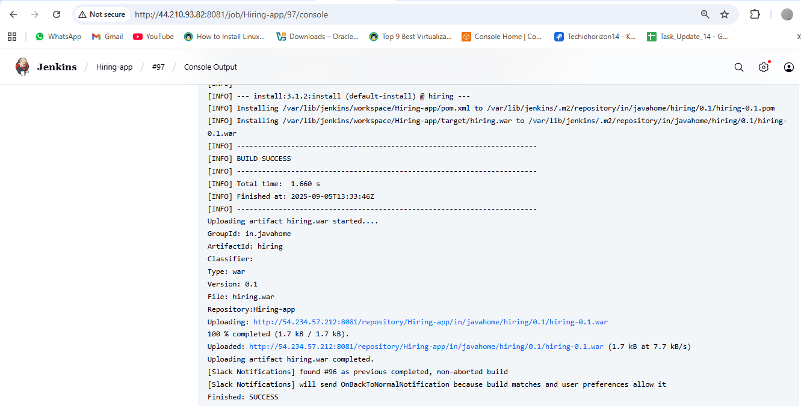
Go to nexus application page can check one artefact repository stored one build outcome.
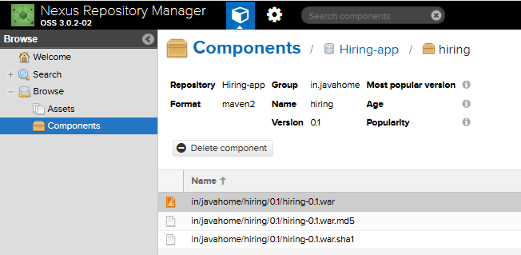
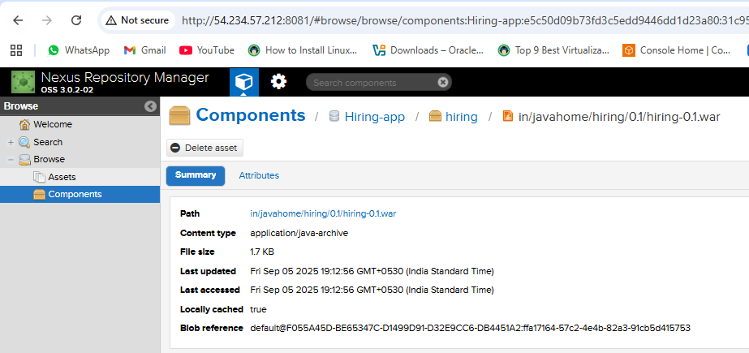

To deploy the tomcat service need to add plugins blow.
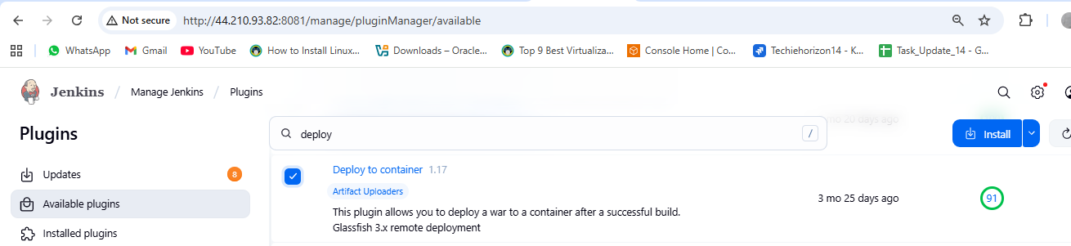
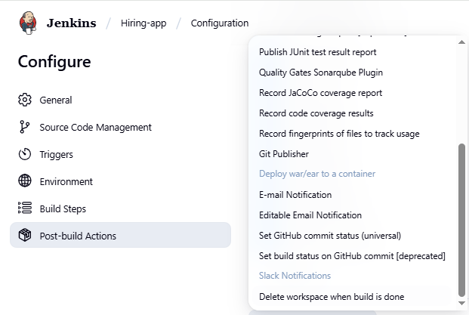
Create Tomcat-ec2 install
yum install -y java-1.8*
cd /opt/
wget https://dlcdn.apache.org/tomcat/tomcat-9/v9.0.109/bin/apache-tomcat-9.0.109.tar.gz
ls
tar xvf apache-tomcat-9.0.109.tar.gz
cd apache-tomcat-9.0.109.tar.gz
ls
cd bin/
bash startup.sh
Then go to browser and check tomcat page running http://<public IP>.8080
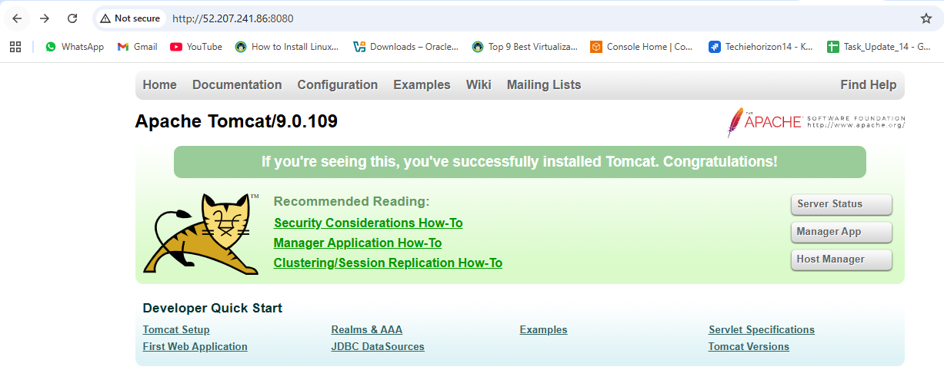
find / -name context.xml
above command gives 4 context.xml files. comment (<!-- & -->) `Value ClassName` field on files which are under webapp directory.
Update users information in the tomcat-users.xml file
Go to tomcat home directory and Add below users to conf/tomcat-user.xml file
<role rolename="manager-gui"/>
<role rolename="manager-script"/>
<role rolename="manager-jmx"/>
<role rolename="manager-status"/>
<user username="admin" password="admin" roles="manager-gui, manager-script, manager-jmx, manager-status"/>
<user username="deployer" password="deployer" roles="manager-script"/>
<user username="tomcat" password="s3cret" roles="manager-gui"/>
After that restart tomcat services to effect these changes
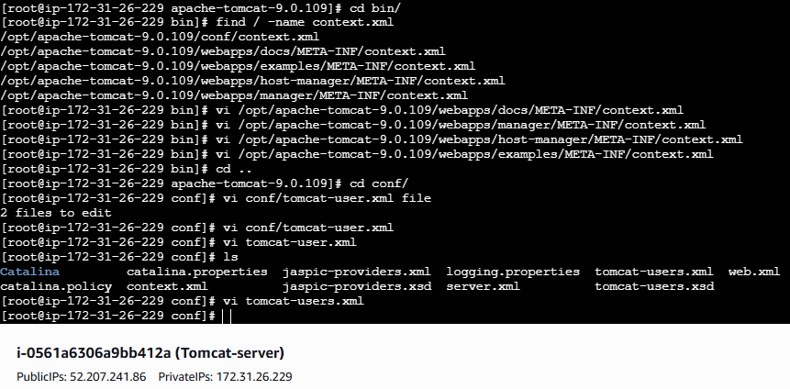
Comment using <!-- -->
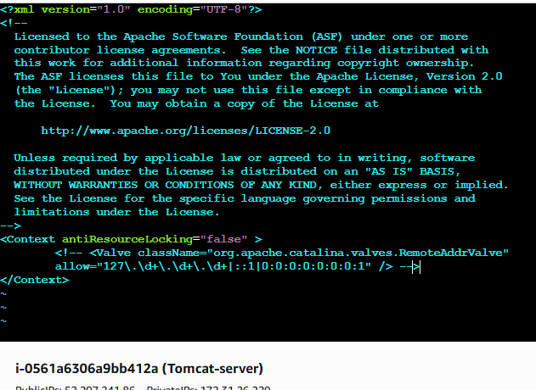
Set role and user
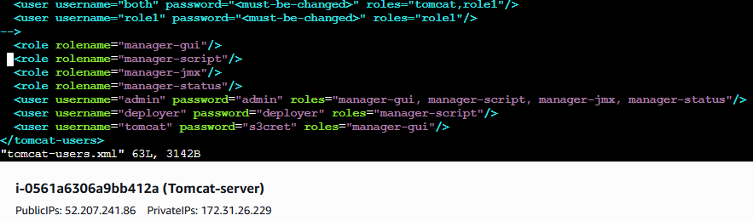
Go to Jenkins>job>configuration>post build actions>deploy war/ear to container
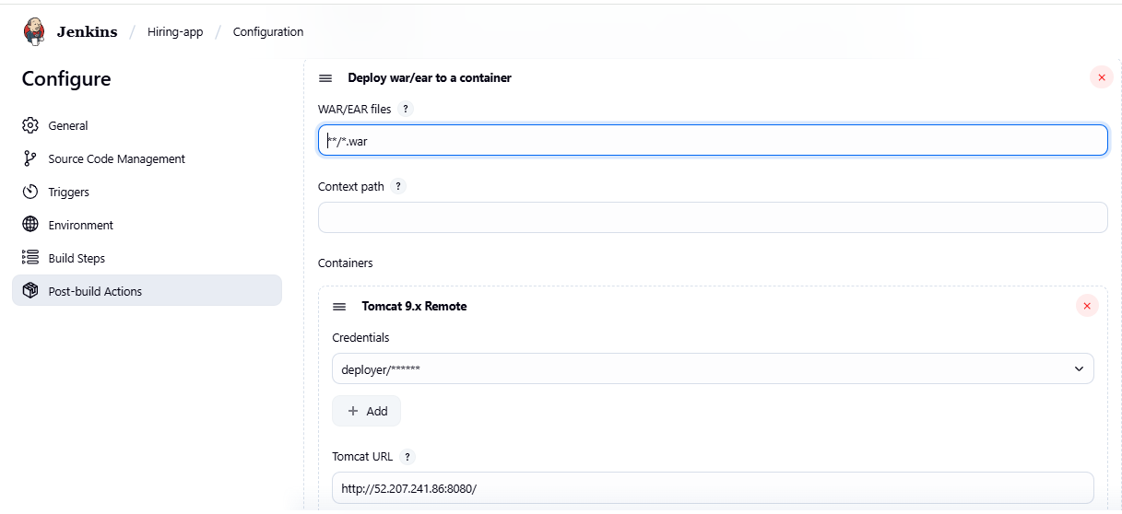
Job is deployed successfully
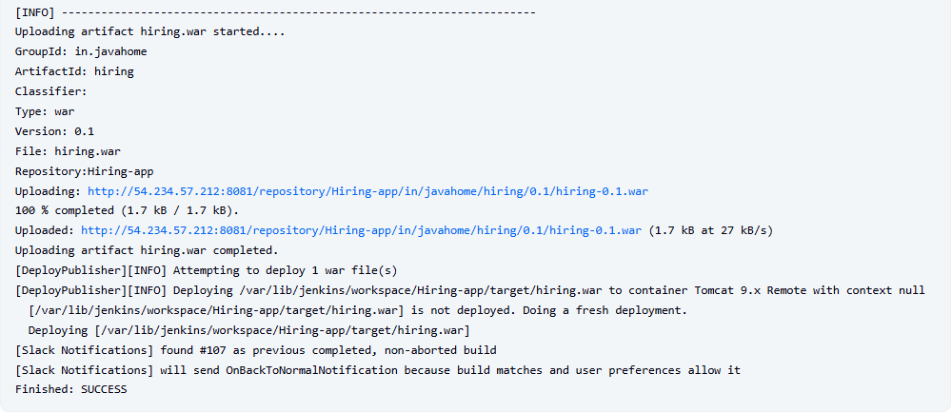
Now we can see one hiring.war file is created in the web application
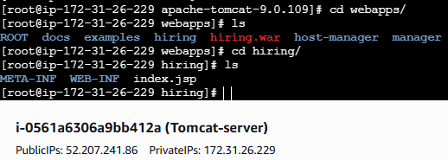
Now check in tomcat at browser we got our application is live.
http://public IP:8080/hiring/
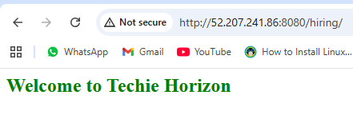

2) Setup a jenkins CICD pipeline using Declarative pipeline using feature-1.1 branch.
https://github.com/betawins/sabear_simplecutomerapp/tree/feature-1.1
stages:
1) Git Clone
2) Sonarqube Integration
3) Maven Compilation
4) Nexus Artifactory
5) Slack Notification
6) Deploy On tomcat
Pre Requisite done.

# 1. Clone the original repo directly
git clone https://github.com/betawins/sabear_simplecutomerapp.git
cd sabear_simplecutomerapp

# 2. Connect to your GitHub repo
Go to GitHub → Create a new empty repository (without README).
Example: https://github.com/imrankhanmohammad257/sabear_simplecutomerapp.git
Add it as remote

git remote add origin https://github.com/imrankhanmohammad257/sabear_simplecutomerapp.git

# 3. Push all branches from original repo
Option 1
git checkout feature-1.1
git push origin feature-1.1
Option 2
git push origin 'refs/remotes/origin/*:refs/heads/*'

—-------------------------------------------------------- OR ---------------------------------------

1. Fork the required git hub repo from another github account.
# 1. Clone your fork (your GitHub repo)
git clone https://github.com/imrankhanmohammad257/sabear_simplecutomerapp.git
cd sabear_simplecutomerapp

# 2. Add the original repo as another remote
git remote add upstream https://github.com/betawins/sabear_simplecutomerapp.git

# 3. Fetch all branches from original repo
git fetch upstream

# 4. Checkout the feature branch you want
git checkout -b feature-1.1 upstream/feature-1.1

# 5. Push it to your repo (fork)
git push origin feature-1.1

—-----------------------------------------------------------------------------------------------------

Jenkins CI/CD Pipeline for Simple Customer App

1. Job Overview
The Simple Customer App Jenkins job automates the following tasks:
- Checkout code from GitHub repository
- Build the project using Maven
- Run SonarQube code analysis
- Deploy the WAR file to Nexus repository
- Deploy the WAR file to Tomcat server
- Send Slack notifications for build status

2. Prerequisites
Before creating the Jenkins job, ensure the following are set up:
- Jenkins server with required plugins:
  - Git Plugin
  - Maven Integration Plugin
  - SonarQube Scanner Plugin
  - Slack Notification Plugin
- Maven installed on Jenkins (e.g., Maven 3.8.4)
- SonarQube server configured in Jenkins
- Nexus repository with admin credentials
- Tomcat server installed and running
- Jenkins credentials created for:
  - Nexus (nexus-creds)
  - Tomcat (tomcat-credentials)
  - Slack (slack_notification)

3. GitHub Repository
- Repository URL:
https://github.com/imrankhanmohammad257/sabear_simplecutomerapp.git
- Branch: feature-1.1
The repository contains the SimpleCustomerApp project, structured as a Maven WAR project.

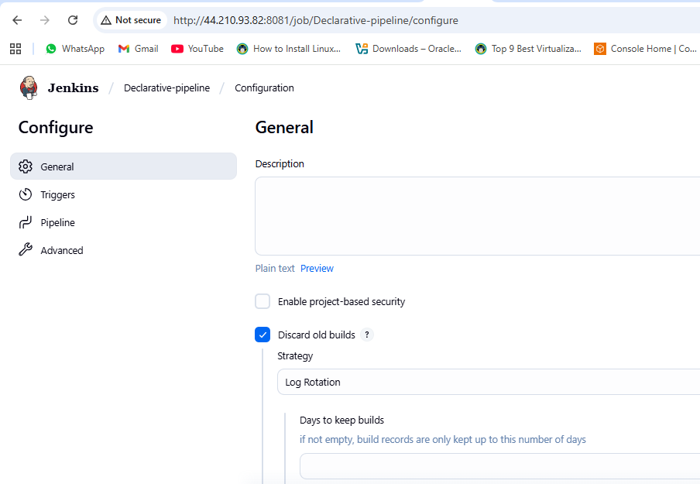
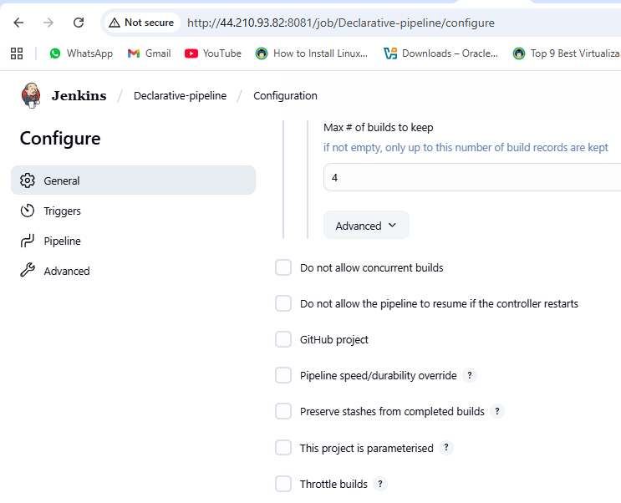
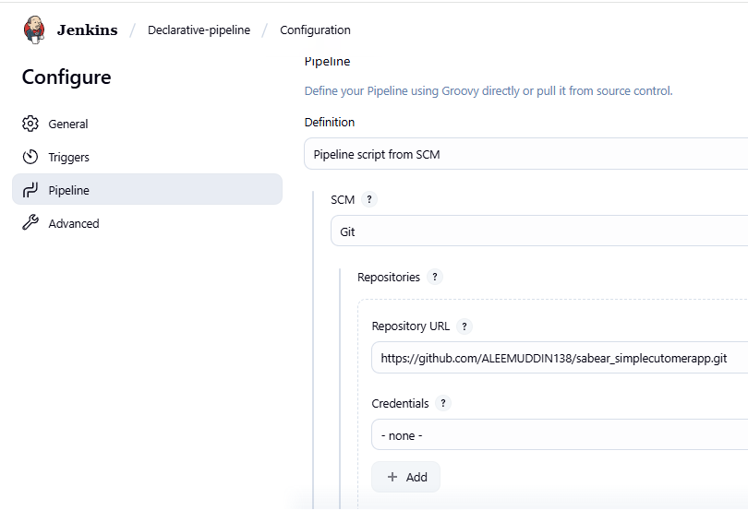
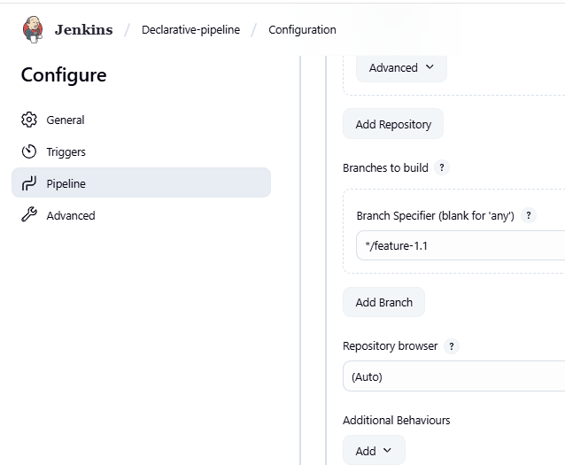
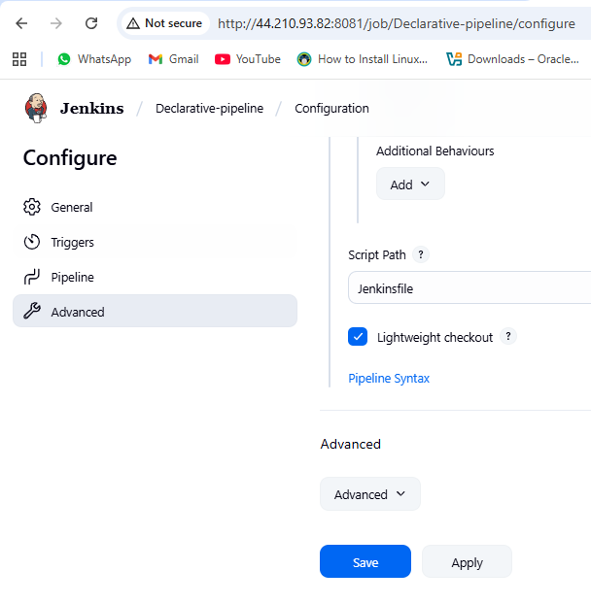

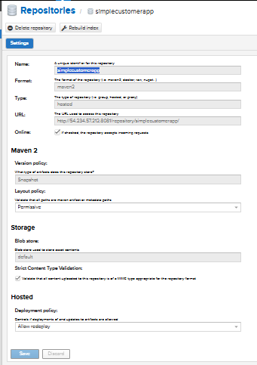
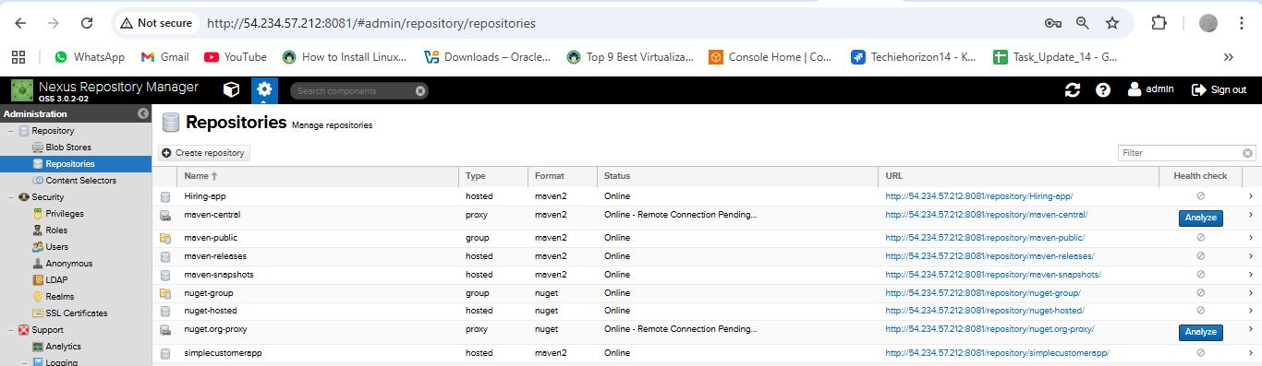
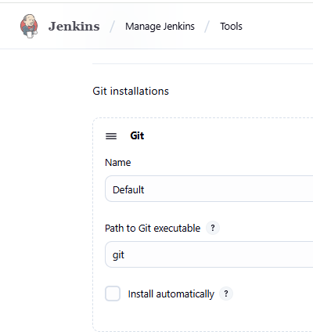
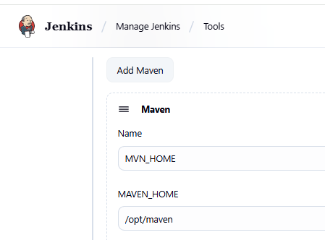
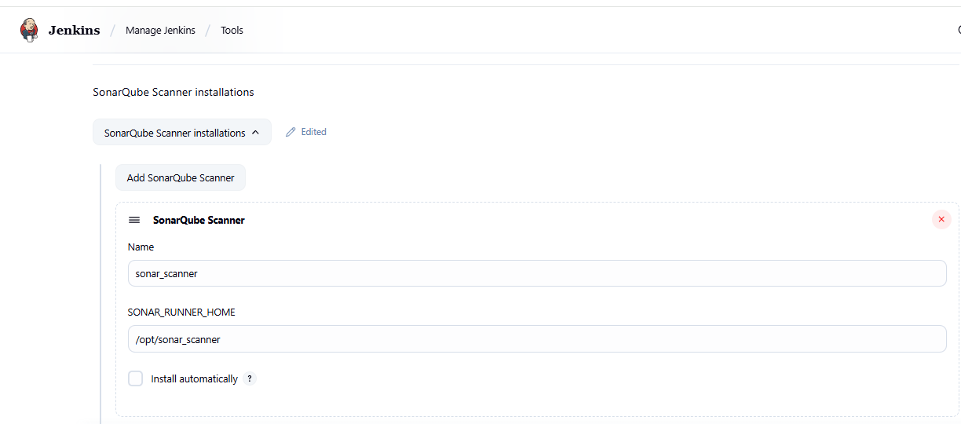
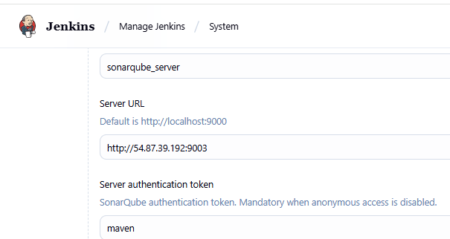
pipeline {
agent any
tools {
maven 'MVN_HOME'
}
environment {
NEXUS_VERSION = "nexus3"
NEXUS_PROTOCOL = "http"
NEXUS_URL = "54.234.57.212:8081"
NEXUS_REPOSITORY = "simplecustomerapp"
NEXUS_CREDENTIAL_ID = "Nexus-server"
SCANNER_HOME = tool 'sonar_scanner'
// Slack details (already configured in Jenkins → Configure System → Slack)
SLACK_CHANNEL = "#jenkins-integration"
}
stages {
stage("clone code") {
steps {
git 'https://github.com/ALEEMUDDIN138/sabear_simplecutomerapp.git'
}
}
stage('Build') {
steps {
sh 'mvn -Dmaven.test.failure.ignore=true clean install'
}
}

stage("SonarCloud") {
steps {
withSonarQubeEnv('sonarqube_server') {
sh '''$SCANNER_HOME/bin/sonar-scanner \
-Dsonar.projectKey=Ncodeit \
-Dsonar.projectName=Ncodeit \
-Dsonar.projectVersion=2.0 \
-Dsonar.sources=/var/lib/jenkins/workspace/$JOB_NAME/src/ \
-Dsonar.binaries=target/classes/com/visualpathit/account/controller/ \
-Dsonar.junit.reportsPath=target/surefire-reports \
-Dsonar.jacoco.reportPath=target/jacoco.exec \
-Dsonar.java.binaries=src/com/room/sample '''
}
}
}
stage("publish to nexus") {
steps {
script {
def pom = readMavenPom file: "pom.xml"
def filesByGlob = findFiles(glob: "target/*.${pom.packaging}")
echo "${filesByGlob[0].name} ${filesByGlob[0].path}"
def artifactPath = filesByGlob[0].path
def artifactExists = fileExists artifactPath

if (artifactExists) {
nexusArtifactUploader(
nexusVersion: NEXUS_VERSION,
protocol: NEXUS_PROTOCOL,
nexusUrl: NEXUS_URL,
groupId: pom.groupId,
version: pom.version,
repository: NEXUS_REPOSITORY,
credentialsId: NEXUS_CREDENTIAL_ID,
artifacts: [
[artifactId: pom.artifactId, classifier: '', file: artifactPath, type: pom.packaging],
[artifactId: pom.artifactId, classifier: '', file: "pom.xml", type: "pom"]
]
)
} else {
error "*** File: ${artifactPath}, could not be found"
}
}
}
}

// stage("Deploy to Tomcat") {
// steps {
// withCredentials([usernamePassword(credentialsId: '6032f458-5f14-4354-9500-645db052e2b5', usernameVariable: 'TOMCAT_USER', passwordVariable: 'TOMCAT_PASS')]) {
// script {
// // Find the WAR file built by Maven
// def warFile = sh(script: "ls target/*.war | head -n 1", returnStdout: true).trim()
// def warName = sh(script: "basename ${warFile} .war | tr '[:upper:]' '[:lower:]'", returnStdout: true).trim()
// echo "Deploying ${warFile} to Tomcat at context path /${warName}..."
// sh """
// curl -u $TOMCAT_USER:$TOMCAT_PASS \\
// -T ${warFile} \\
// "http://52.207.241.86:8080/manager/text/deploy?path=/${warName}&update=true"
stage("Deploy to Tomcat") {
steps {
withCredentials([usernamePassword(credentialsId: '6032f458-5f14-4354-9500-645db052e2b5', usernameVariable: 'TOMCAT_USER', passwordVariable: 'TOMCAT_PASS')]) {
script {
// Find the WAR file built by Maven
def warFile = sh(script: "ls target/*.war | head -n 1", returnStdout: true).trim()
echo "Deploying ${warFile} to Tomcat at context path /simplecustomerapp ..."
sh """
curl -u $TOMCAT_USER:$TOMCAT_PASS \
-T ${warFile} \
"http://52.207.241.86:8080/manager/text/deploy?path=/simplecustomerapp&update=true"
"""
}
}
}
}
stage("Slack Notification") {
steps {
slackSend(
channel: "${SLACK_CHANNEL}",
color: "#36A64F",
message: "Declarative pipeline for *Simple Customer App* has been successfully deployed in Tomcat :white_check_mark: by ALEEM for Job: ${env.JOB_NAME} [${env.BUILD_NUMBER}]"
)
}
}
}
}
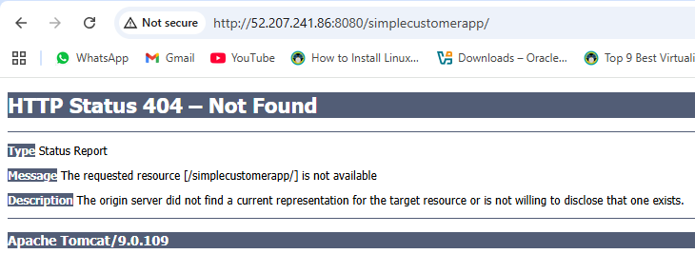
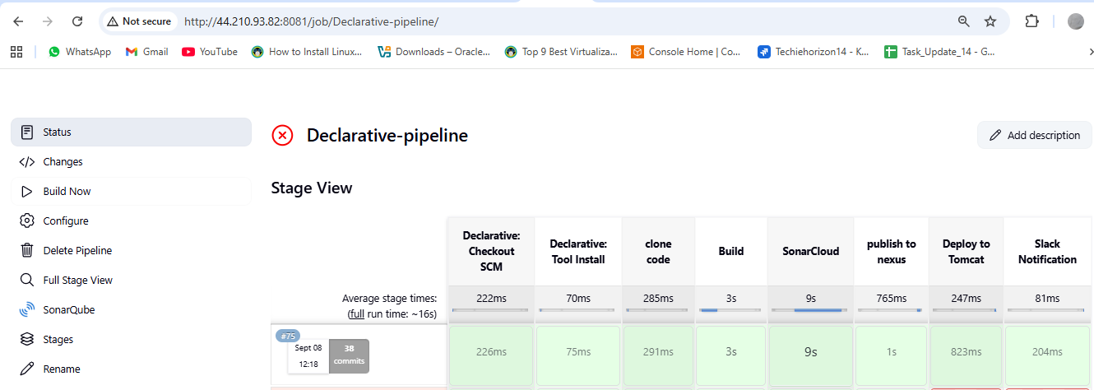
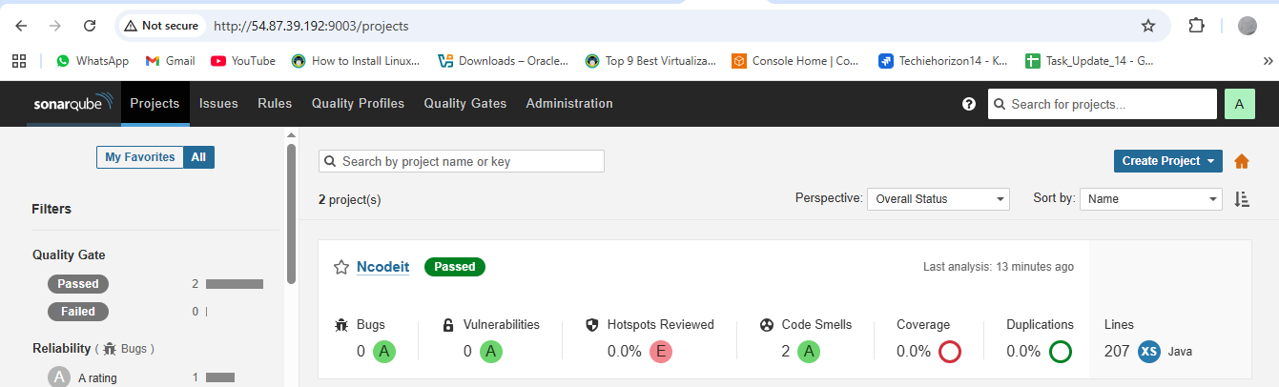
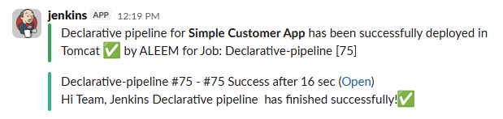

3) Setup a jenkins CICD pipeline using Scripted pipeline using feature-1.1 branch.
https://github.com/betawins/sabear_simplecutomerapp/tree/feature-1.1
stages:
1) Git Clone
2) Sonarqube Integration
3) Maven Compilation
4) Nexus Artifactory
5) Slack Notification
6) Deploy On tomcat

1) Prereqs you set up
- Jenkins controller with plugins: Pipeline, Git, Maven Integration, SonarQube Scanner, Credentials, Slack.
- Tools in Jenkins → Global Tool Config
  - JDK (e.g., Java 17)
  - Maven named Maven-3.8.4
- Servers
  - SonarQube reachable and configured in Jenkins as server name SonarQube.
  - Nexus (two repos: maven-snapshots and releases).
  - Tomcat with manager-script user enabled.
- Credentials in Jenkins → Credentials
  - nexus-creds (username/password)
  - tomcat-credentials (username/password)
  - slack_notification (Slack token for your workspace)
- Maven settings on the Jenkins box: /var/lib/jenkins/.m2/settings.xml with matching <server> IDs for your POM:
<distributionManagement>
<repository>
<id>releases</id>
<url>http://54.209.186.138:8081/repository/maven-releases/</url>
</repository>
<snapshotRepository>
<id>snapshots</id>
<url>http://54.209.186.138:8081/repository/maven-snapshots/</url>
</snapshotRepository>
</distributionManagement>

2) The Scripted Pipeline you ran
Repo & branch: https://github.com/imrankhanmohammad257/sabear_simplecutomerapp.git @ feature-1.1
node {
stage('Git Clone') {
git branch: 'feature-1.1',
url: 'https://github.com/imrankhanmohammad257/sabear_simplecutomerapp.git'
}

stage('SonarQube Analysis') {
withSonarQubeEnv('SonarQube') {
sh 'mvn sonar:sonar'
}
}

stage('Maven Compilation') {
def mvnHome = tool name: 'Maven-3.8.4', type: 'maven'
sh "${mvnHome}/bin/mvn clean compile"
}

stage('Deploy to Nexus') {
withCredentials([usernamePassword(credentialsId: 'nexus-creds', usernameVariable: 'NEXUS_USER', passwordVariable: 'NEXUS_PASS')]) {
sh '''
mvn clean deploy -DskipTests --settings /var/lib/jenkins/.m2/settings.xml
'''
}
}

stage('Slack Notification') {
slackSend(
channel: '#jenkins-integration',
color: 'good',
message: "Jenkins Scripted Pipeline job for *sabear_simplecutomerapp (feature-1.1)* finished successfully! ✅"
)
}

stage('Deploy to Tomcat') {
withCredentials([usernamePassword(credentialsId: 'tomcat-credentials', usernameVariable: 'TOMCAT_USER', passwordVariable: 'TOMCAT_PASS')]) {
sh '''
set -e

WAR_FILE=$(ls target/*.war | head -n 1)

echo "WAR file to deploy: $WAR_FILE"

echo "Undeploying old app..."
curl -s -o /dev/null -w "%{http_code}\\n" -u $TOMCAT_USER:$TOMCAT_PASS \
"http://54.87.222.232:8080/manager/text/undeploy?path=/customerapp"

echo "Deploying new WAR..."
curl -s -o /dev/null -w "%{http_code}\\n" -u $TOMCAT_USER:$TOMCAT_PASS \
-T "$WAR_FILE" \
"http://54.87.222.232:8080/manager/text/deploy?path=/customerapp&update=true"

echo "Deployment completed."
'''
}
}

}

3) What happened in each stage (what you observed)
- Git Clone
Jenkins pulled feature-1.1 into the job workspace.
- Maven Build/Package
  - Executed mvn clean package -DskipTests.
  - Produced target/SimpleCustomerApp-1.0-SNAPSHOT.war.
- SonarQube Analysis
  - Ran mvn sonar:sonar under withSonarQubeEnv('SonarQube').
  - SonarQube accepted the report (dashboard link showed analysis OK).
- Nexus Deploy
  - Attempted mvn deploy.
  - You initially hit issues:
    - 401 Unauthorized → fixed by ensuring settings.xml <servers> IDs matched your POM’s <distributionManagement> IDs and by using Jenkins credentials.
    - Connection timed out → pointed Maven to the correct Nexus IP/port.
  - After fixes, artifacts upload to snapshots repo (because version is 1.0-SNAPSHOT).
- Deploy on Tomcat
  - You added an undeploy first call to avoid stale app:
.../manager/text/undeploy?path=/customerapp
  - Then deployed the freshly built WAR to context /customerapp with update=true.
  - Tomcat logs (tail -f /opt/tomcat/logs/catalina.out) confirmed (un)deploy events.
- Slack Notification
Sent status messages to #jenkins-integration using slack_notification token.
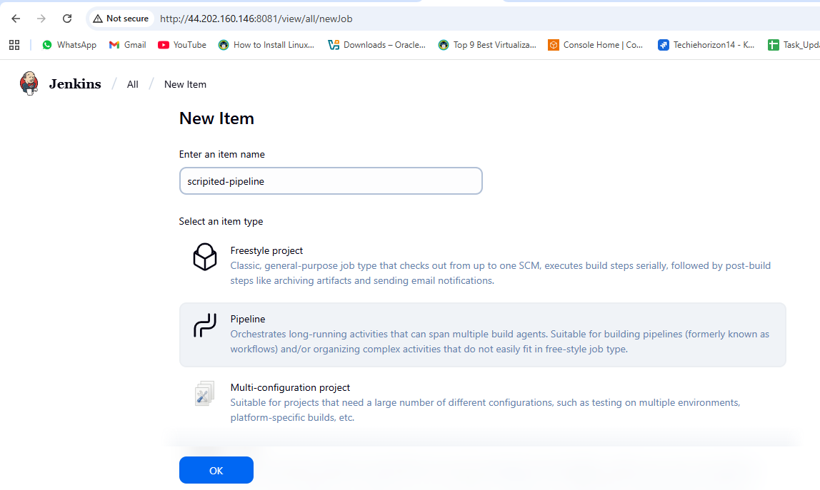
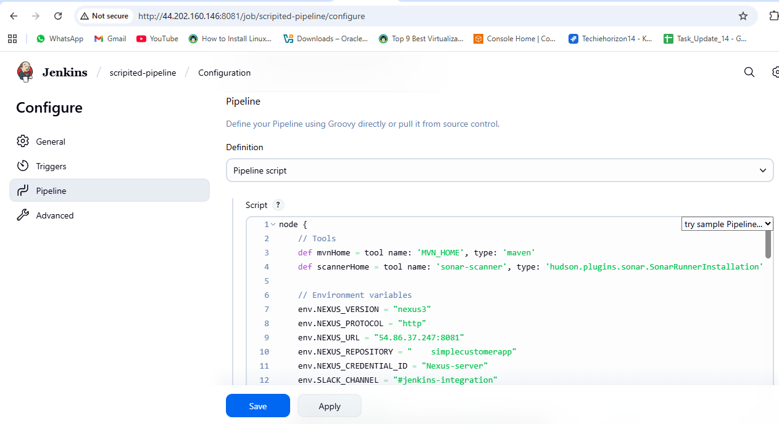
node {
// Tools
def mvnHome = tool name: 'MVN_HOME', type: 'maven'
def scannerHome = tool name: 'sonar_scanner', type: 'hudson.plugins.sonar.SonarRunnerInstallation'

// Environment variables
env.NEXUS_VERSION = "nexus3"
env.NEXUS_PROTOCOL = "http"
env.NEXUS_URL = "54.86.37.247:8081"
env.NEXUS_REPOSITORY = "simplecustomerapp"
env.NEXUS_CREDENTIAL_ID = "Nexus-server"
env.SLACK_CHANNEL = "#jenkins-integration"

stage("Clone Code") {
git 'https://github.com/ALEEMUDDIN138/sabear_simplecutomerapp.git'
}

stage("Build") {
sh "${mvnHome}/bin/mvn -Dmaven.test.failure.ignore=true clean install"
}

stage("SonarCloud") {
withSonarQubeEnv('sonarqube_server') {
sh """
${scannerHome}/bin/sonar-scanner \
-Dsonar.projectKey=Ncodeit \
-Dsonar.projectName=Ncodeit \
-Dsonar.projectVersion=2.0 \
-Dsonar.sources=${WORKSPACE}/src/ \
-Dsonar.binaries=target/classes/com/visualpathit/account/controller/ \
-Dsonar.junit.reportsPath=target/surefire-reports \
-Dsonar.jacoco.reportPath=target/jacoco.exec \
-Dsonar.java.binaries=src/com/room/sample
"""
}
}

stage("Publish to Nexus") {
script {
def pom = readMavenPom file: "pom.xml"
def filesByGlob = findFiles(glob: "target/*.${pom.packaging}")
echo "${filesByGlob[0].name} ${filesByGlob[0].path}"
def artifactPath = filesByGlob[0].path
def artifactExists = fileExists artifactPath
if (artifactExists) {
nexusArtifactUploader(
nexusVersion: env.NEXUS_VERSION,
protocol: env.NEXUS_PROTOCOL,
nexusUrl: env.NEXUS_URL,
groupId: pom.groupId,
version: pom.version,
repository: env.NEXUS_REPOSITORY,
credentialsId: env.NEXUS_CREDENTIAL_ID,
artifacts: [
[artifactId: pom.artifactId, classifier: '', file: artifactPath, type: pom.packaging],
[artifactId: pom.artifactId, classifier: '', file: "pom.xml", type: "pom"]
]
)
} else {
error "*** File: ${artifactPath}, could not be found"
}
}
}

stage("Deploy to Tomcat") {
withCredentials([usernamePassword(credentialsId: '6032f458-5f14-4354-9500-645db052e2b5', usernameVariable: 'TOMCAT_USER', passwordVariable: 'TOMCAT_PASS')]) {
script {
def warFile = sh(script: "ls target/*.war | head -n 1", returnStdout: true).trim()
echo "Deploying ${warFile} to Tomcat at context path /simplecustomerapp ..."
sh """
curl -u $TOMCAT_USER:$TOMCAT_PASS \
-T ${warFile} \
"http://3.84.151.154:8080/manager/text/deploy?path=/simplecustomerapp&update=true"
"""
}
}
}

stage("Slack Notification") {
slackSend(
channel: "${env.SLACK_CHANNEL}",
color: "#36A64F",
message: "Scripted pipeline for *Simple Customer App* has been successfully deployed in Tomcat :white_check_mark: by Aleem for Job: ${env.JOB_NAME} [${env.BUILD_NUMBER}]"
)
}
}
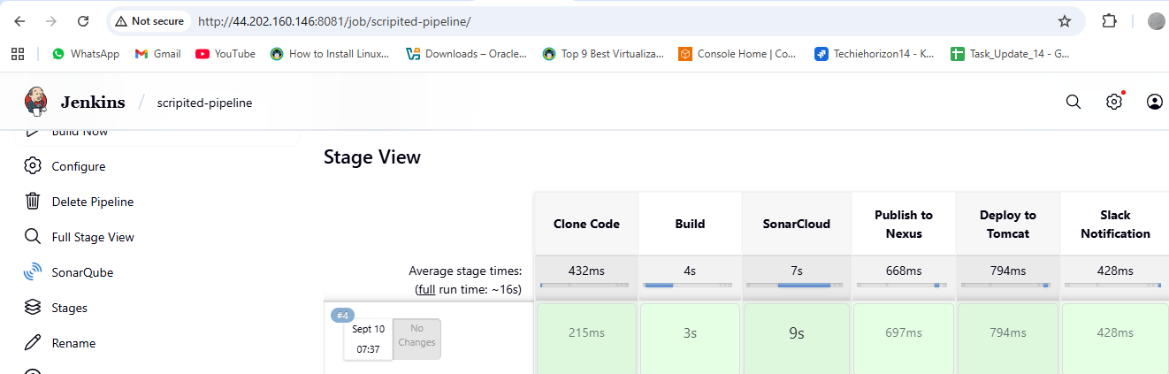
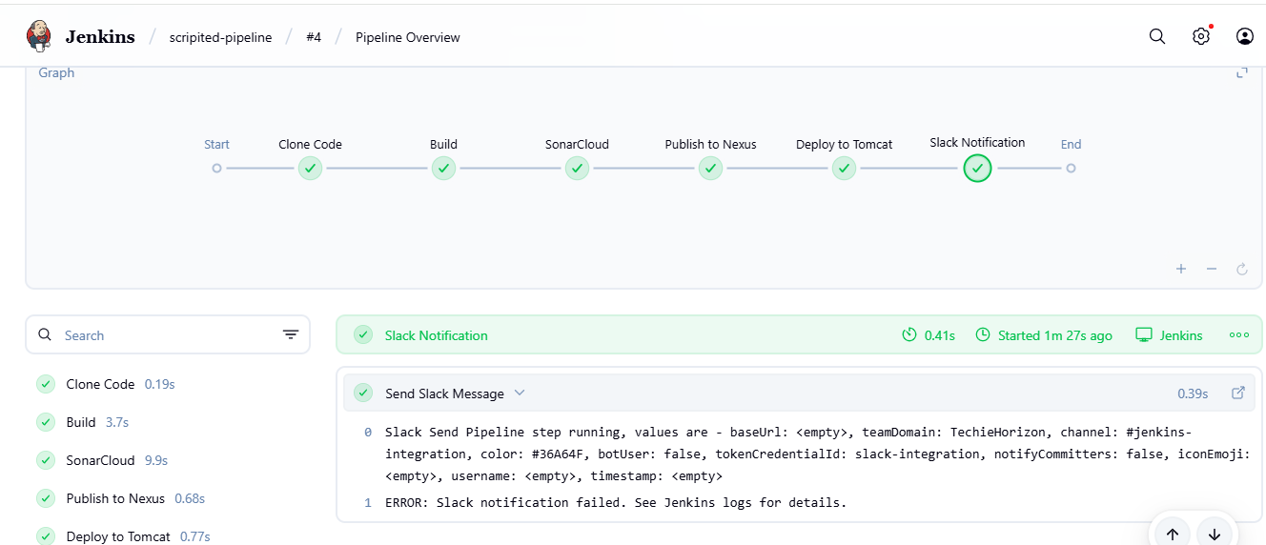
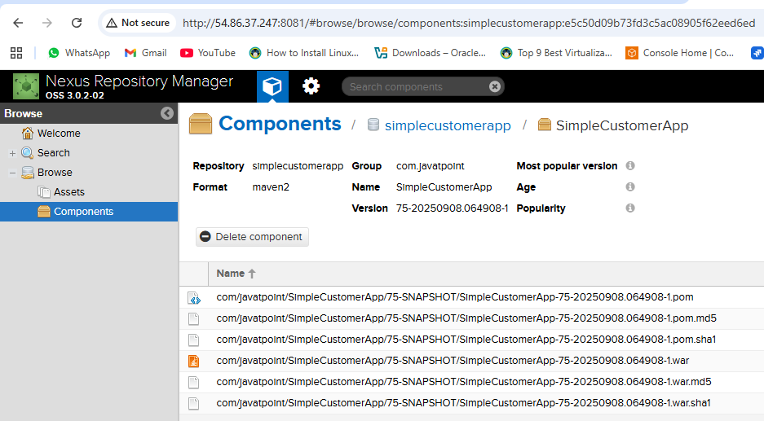
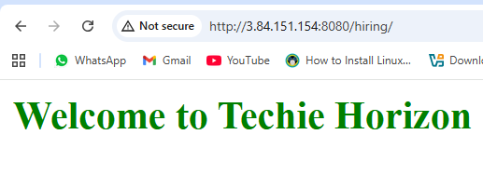

4) Write sample skeleton of pipelines.
Scripted Pipeline
This offers more flexibility and control, using Groovy scripting.
While powerful, it requires a deeper understanding of Groovy and Jenkins internals

Scripted Pipeline Skeleton
node {
// Define tools and env if needed
def mvnHome = tool name: 'MVN_HOME', type: 'maven'

stage('Checkout') {
git branch: 'feature-1.1',
url: 'https://github.com/your-repo/your-project.git'
}

stage('Build') {
sh "${mvnHome}/bin/mvn clean install -DskipTests=true"
}

stage('SonarQube Analysis') {
withSonarQubeEnv('sonarqube_server') {
sh "${mvnHome}/bin/mvn sonar:sonar"
}
}

stage('Publish to Nexus') {
sh "${mvnHome}/bin/mvn deploy"
}

stage('Deploy to Tomcat') {
sh "cp target/*.war /opt/tomcat/webapps/"
}

stage('Notify Slack') {
slackSend channel: '#jenkins-integration',
color: 'good',
message: "✅ Build & Deploy successful!"
}
}

Declarative Pipeline Skeleton
a) Declarative Pipeline
This is a more structured and opinionated syntax, making it easier to read and maintain.
This structure is ideal for most use cases and is recommended for new users.

pipeline {
agent any

tools {
maven "MVN_HOME"
}

environment {
BRANCH_NAME = "feature-1.1"
SONARQUBE_ENV = "sonarqube_server"
}

stages {
stage('Checkout') {
steps {
git branch: "${BRANCH_NAME}",
url: 'https://github.com/your-repo/your-project.git'
}
}

stage('Build') {
steps {
sh "mvn clean install -DskipTests=true"
}
}

stage('SonarQube Analysis') {
steps {
withSonarQubeEnv("${SONARQUBE_ENV}") {
sh "mvn sonar:sonar"
}
}
}

stage('Publish to Nexus') {
steps {
sh "mvn deploy"
}
}

stage('Deploy to Tomcat') {
steps {
sh "cp target/*.war /opt/tomcat/webapps/"
}
}

stage('Notify Slack') {
steps {
slackSend(channel: '#jenkins-integration',
color: 'good',
message: "✅ Build & Deploy successful!")
}
}
}
}

5) Create a parameterized job in jenkins.
https://github.com/betawins/spring3-mvc-maven-xml-hello-world-1.git

Step 1: Log in to Jenkins
- Open your Jenkins URL in a browser:
http://<JENKINS_SERVER_IP>:8080

Step 2: Create a New Job
- Click “New Item” in Jenkins dashboard.
- Enter a name for your job, e.g., Spring3-MVC-Parameterized.
- Select “Freestyle project” or “Pipeline” (for this example, we will use Pipeline).
- Click OK.

Step 3: Enable Parameterization
- In the job configuration, check “This project is parameterized”.
- Click “Add Parameter” and select String Parameter.
- Configure the parameter:
  - Name: BRANCH_NAME (used to choose Git branch)
  - Default Value: main
  - Description: Enter the Git branch to build
- Add another parameter if needed:
  - Example: DEPLOY_ENV (to choose environment like dev, test, prod)

Step 4: Configure Pipeline
- Scroll to Pipeline section.
- Select Pipeline script or Pipeline script from SCM:
  - SCM: Git
  - Repository URL:
https://github.com/betawins/spring3-mvc-maven-xml-hello-world-1.git
  - Branch Specifier: ${BRANCH_NAME} (uses the parameter)
  - Script Path: Jenkinsfile (if using Pipeline script from repo)

Step 5: Add Build Stages
If using Pipeline Script directly in Jenkins:

Step 6: Save and Run Job
- Click Save.
- Click Build with Parameters.
- Enter values for parameters:
  - BRANCH_NAME: e.g., main or any branch in Git repo
  - DEPLOY_ENV: e.g., dev
- Click Build.

Step 7: Verify WAR Artifact
- On Jenkins, navigate to job workspace:
/var/lib/jenkins/workspace/Spring3-MVC-Parameterized/target/

Step 8: Deploy to Tomcat
- Copy WAR file to Tomcat EC2:
scp /var/lib/jenkins/workspace/Spring3-MVC-Parameterized/target/hello-world.war ec2-user@<TOMCAT_IP>:/opt/tomcat/webapps/
tail -f /opt/tomcat/logs/catalina.out
http://<TOMCAT_IP>:8080/hello-world/

Step 9: Add Slack Notifications (Optional)
- Install Slack Notification Plugin in Jenkins.
- Configure Slack credentials in Manage Jenkins → Configure System.
- Add in Pipeline post section:
post {
success {
slackSend(channel: '#jenkins', color: 'good', message: "✅ Build Successful: ${env.JOB_NAME} #${env.BUILD_NUMBER}")
}
failure {
slackSend(channel: '#jenkins', color: 'danger', message: "❌ Build Failed: ${env.JOB_NAME} #${env.BUILD_NUMBER}")
}
}
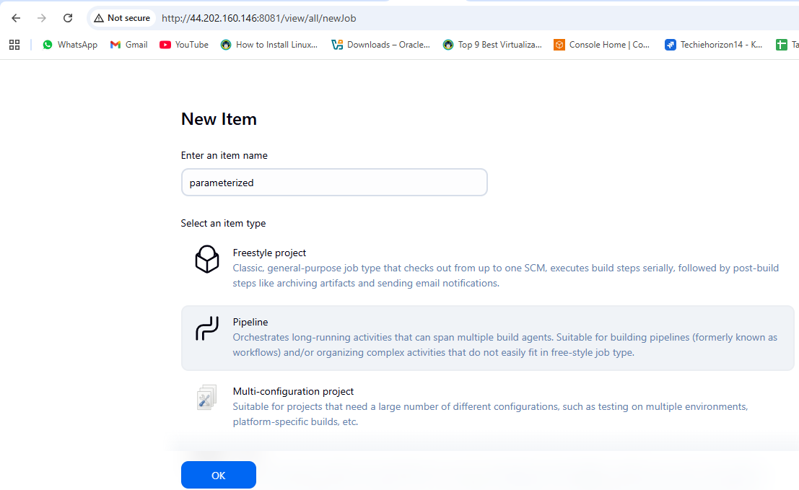

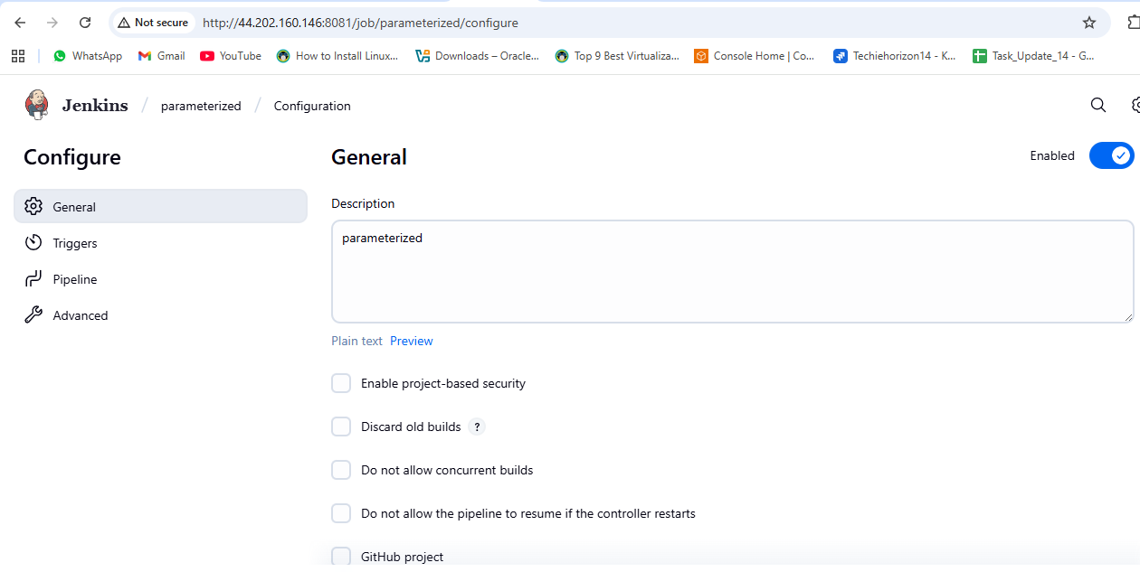
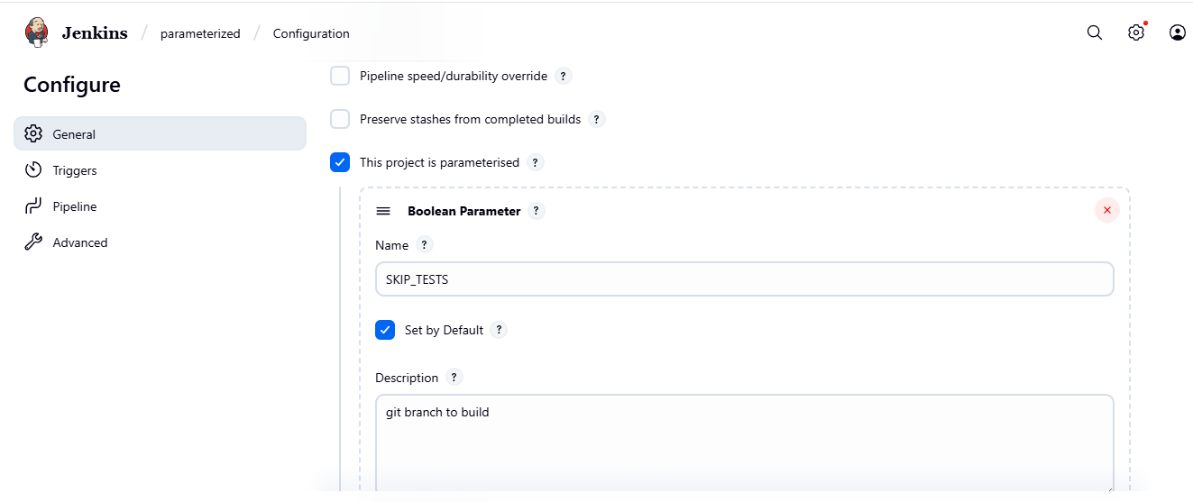
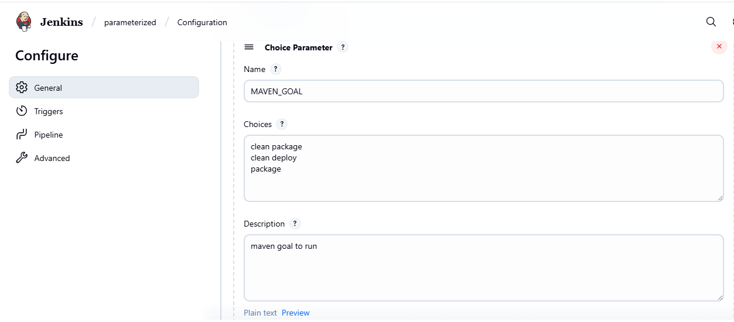
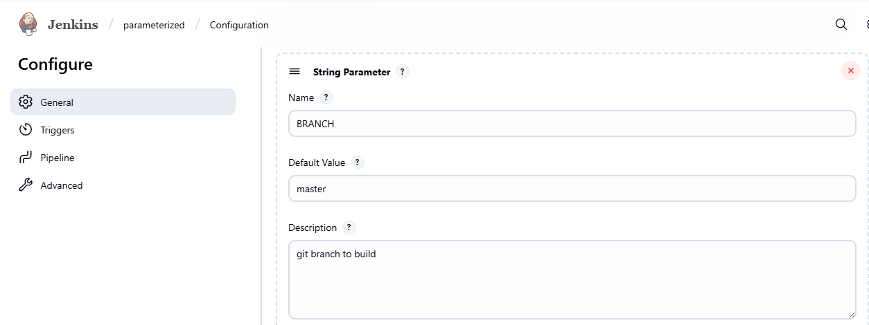
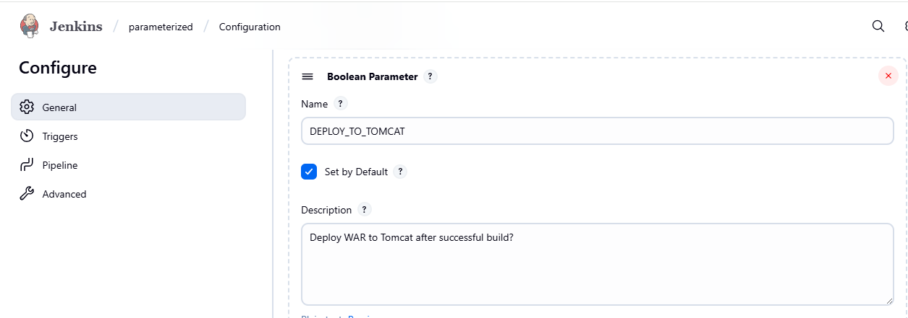
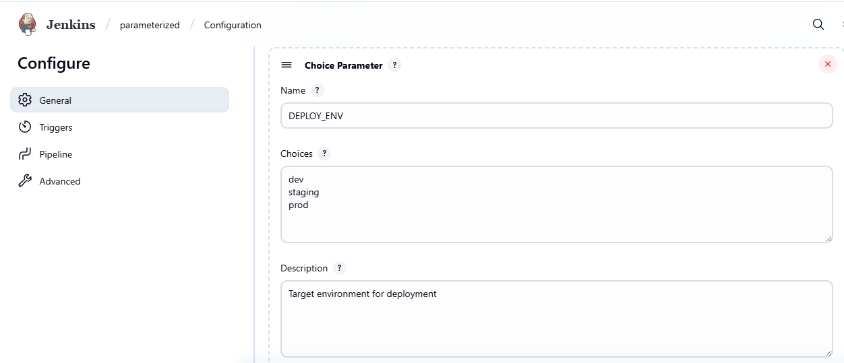
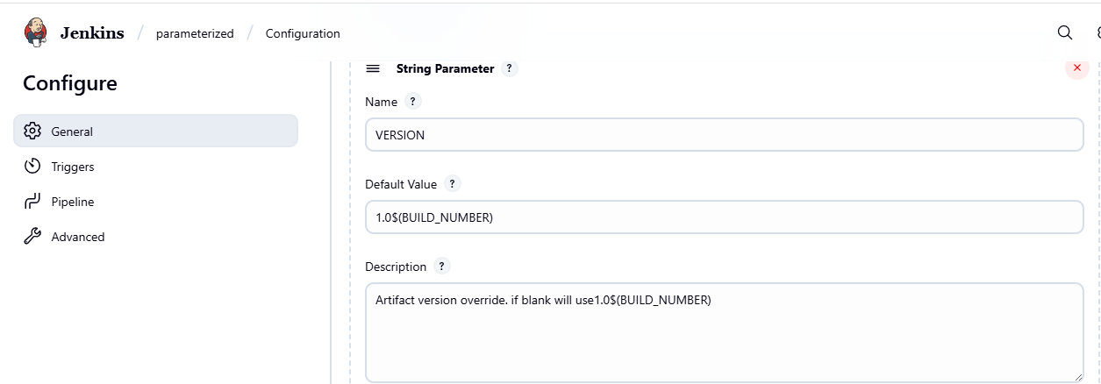
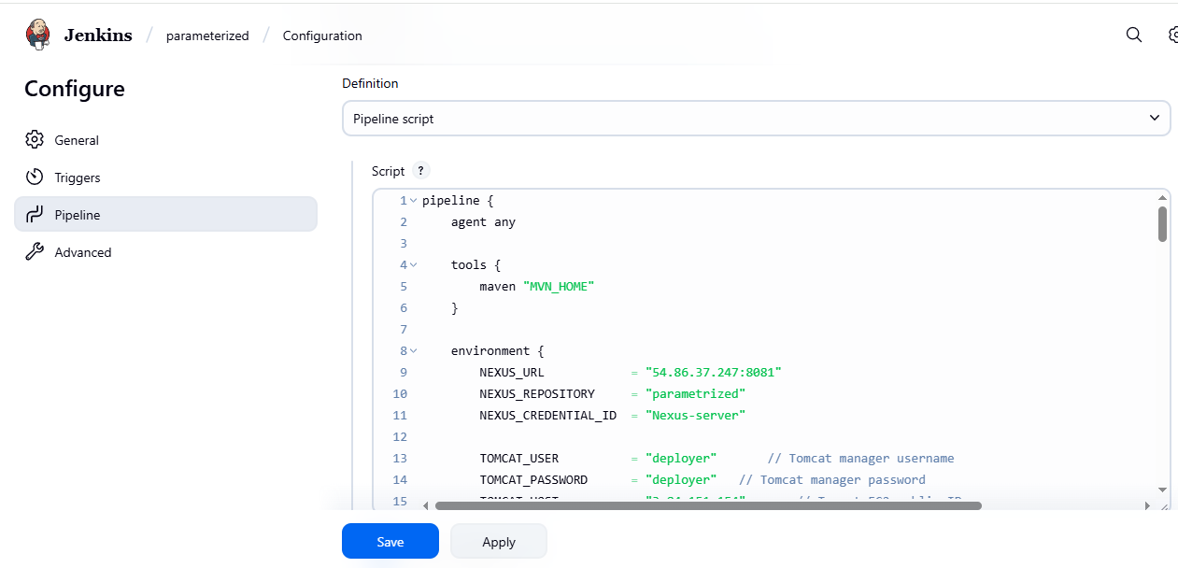
pipeline {
agent any

tools {
maven "MVN_HOME"
}

environment {
NEXUS_URL = "54.86.37.247:8081"
NEXUS_REPOSITORY = "parametrized"
NEXUS_CREDENTIAL_ID = "Nexus-server"

TOMCAT_USER = "deployer" // Tomcat manager username
TOMCAT_PASSWORD = "deployer" // Tomcat manager password
TOMCAT_HOST = "3.84.151.154" // Tomcat EC2 public IP
TOMCAT_PORT = "8080"
SLACK_CHANNEL = "#jenkins-integration"
SLACK_CREDENTIAL_ID = "slack_notification"
}

stages {
stage("Clone code") {
steps {
git 'https://github.com/ALEEMUDDIN138/spring3-mvc-maven-xml-hello-world-1.git'
}
}

stage("Maven build") {
steps {
sh 'mvn -B -Dmaven.test.failure.ignore=true clean install'
}
}

stage('Publish to Nexus') {
steps {
script {
def pom = readMavenPom file: 'pom.xml'
def artifactVersion = pom.version
def groupId = pom.groupId
def artifactId = pom.artifactId

def warFiles = findFiles(glob: "target/${artifactId}-${artifactVersion}.war")
if (warFiles.length == 0) {
error "WAR file not found: target/${artifactId}-${artifactVersion}.war"
}
def warFile = warFiles[0].path

echo "Uploading artifact: ${warFile} (version: ${artifactVersion}) to Nexus"

nexusArtifactUploader(
artifacts: [[
artifactId: artifactId,
classifier: '',
file: warFile,
type: 'war'
], [
artifactId: artifactId,
classifier: '',
file: 'pom.xml',
type: 'pom'
]],
credentialsId: NEXUS_CREDENTIAL_ID,
groupId: groupId,
version: artifactVersion,
repository: NEXUS_REPOSITORY
)
}
}
}

stage("Deploy to Tomcat") {
steps {
script {
def pom = readMavenPom file: 'pom.xml'
def artifactVersion = pom.version
def artifactId = pom.artifactId
def warFile = "target/${artifactId}-${artifactVersion}.war"

echo "Deploying ${warFile} to Tomcat at ${TOMCAT_HOST}:${TOMCAT_PORT}"

sh """
curl -u ${TOMCAT_USER}:${TOMCAT_PASSWORD} \
-T ${warFile} \
"http://${TOMCAT_HOST}:${TOMCAT_PORT}/manager/text/deploy?path=/${artifactId}&update=true"
"""
}
}
}
}

post {
success {
slackSend(
channel: SLACK_CHANNEL,
color: 'good',
message: "✅ Pipeline '${env.JOB_NAME} [${env.BUILD_NUMBER}]' completed successfully! <${env.BUILD_URL}|Open Build>"
)
cleanWs()
}
failure {
slackSend(
channel: SLACK_CHANNEL,
color: 'danger',
message: "❌ Pipeline '${env.JOB_NAME} [${env.BUILD_NUMBER}]' failed! <${env.BUILD_URL}|Open Build>"
)
cleanWs()
}
always {
echo "Cleaning workspace..."
cleanWs()
}
}
}
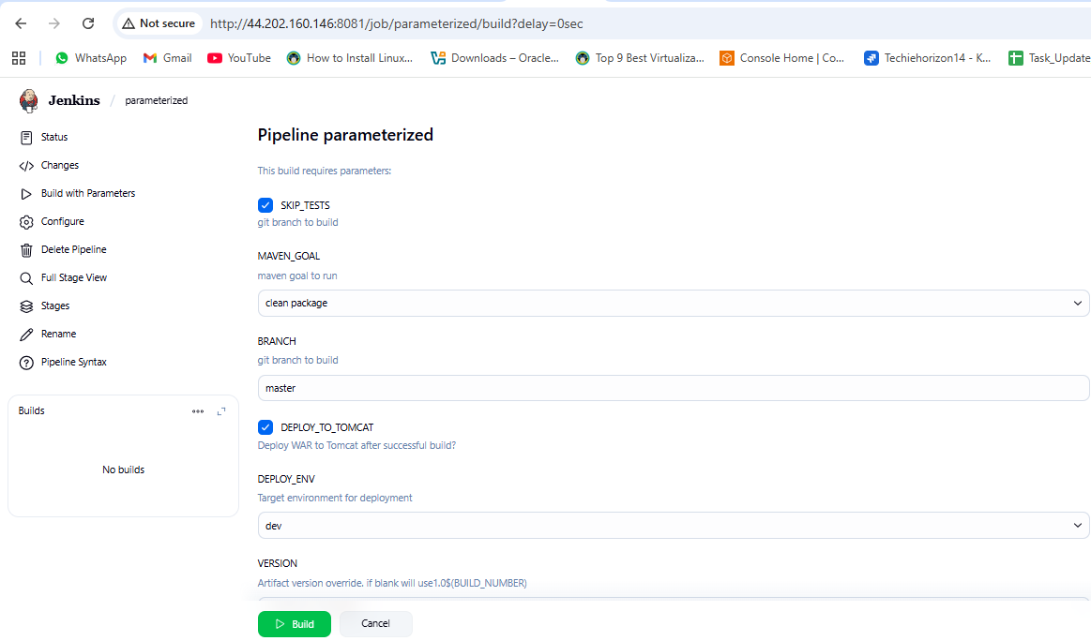
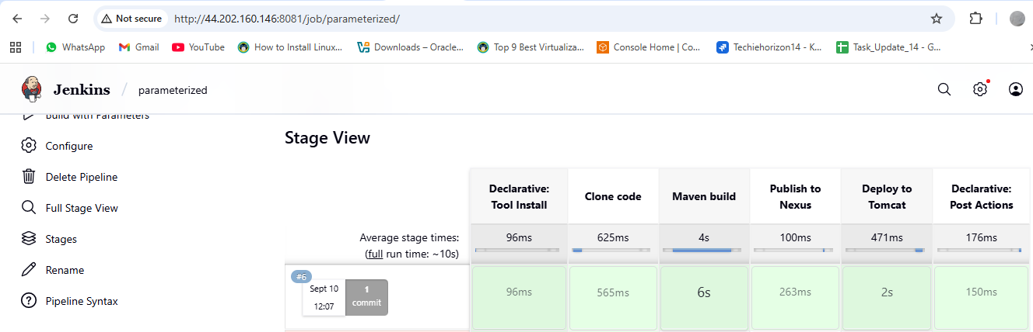
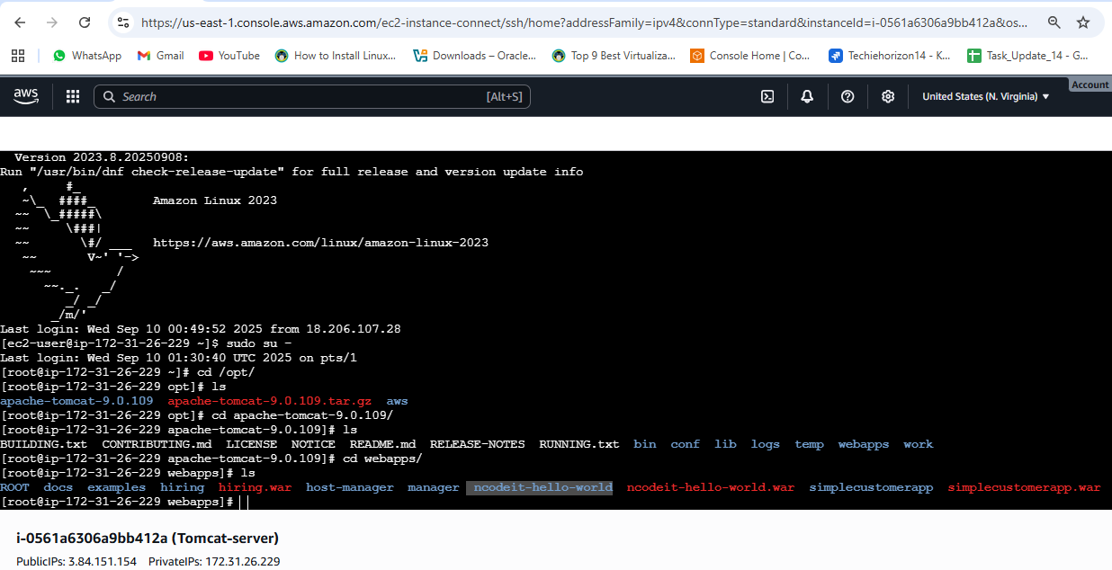
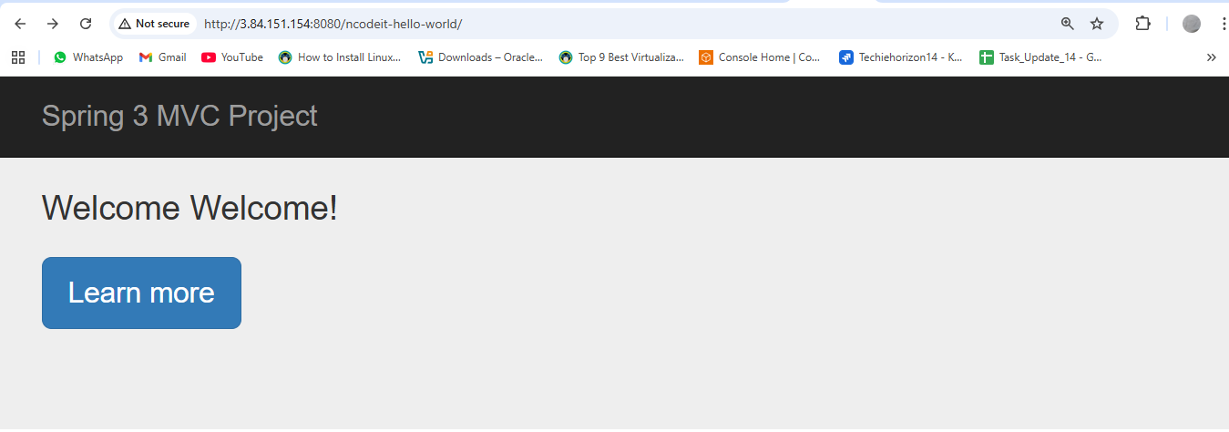

6) Setup one slave machine for jenkins.
GitHub
GitHub - betawins/hiring-app
Contribute to betawins/hiring-app development by creating an account on GitHub. (33 kB)
https://github.com/betawins/hiring-app.git
GitHub
GitHub - betawins/sabear_simplecutomerapp at feature-1.1
Contribute to betawins/sabear_simplecutomerapp development by creating an account on GitHub. (34 kB)
https://github.com/betawins/sabear_simplecutomerapp/tree/feature-1.1
GitHub
GitHub - betawins/spring3-mvc-maven-xml-hello-world-1: Maven + Spring 3 MVC hello world example (XML)
Maven + Spring 3 MVC hello world example (XML). Contribute to betawins/spring3-mvc-maven-xml-hello-world-1 development by creating an account on GitHub.
- Create jenkins ec2 installed java , git and jenkins.
- Create or launch instances slave1-ec2 Installed java and git on slave1-ec2(jenkins no need in slave1-ec2)
- sudo yum install -y git
- sudo dnf install -y java-17-amazon-corretto
- copy the key gen of slave1-ec2 → ssh-keygen
- cd .ssh
- cat id_rsa.pub > authorized_keys
- chmod 700 authorized_keys
- In root → mkdir slave1-workspace

Steps on Master Machine
- Login to master machine.
- Switch to root user.
- Create Jenkins SSH directory:
mkdir -p /var/lib/jenkins/.ssh
cd /var/lib/jenkins/.ssh
- ssh-keyscan -H SLAVE-NODE-PUBLIC-IP >> /var/lib/jenkins/.ssh/known_hosts
- chown jenkins:jenkins /var/lib/jenkins/.ssh/known_hosts
- chmod 644 /var/lib/jenkins/.ssh/known_hosts

E) Create the node in Jenkins GUI
- Manage Jenkins → Nodes → New Node
- Name: slave1 → Type: Permanent Agent
- Remote root directory: /home/ec2-user
- This path is taken from slave machine
- Slave ec2 → cat /etc/passwd
- Create mkdir slave1-workspace(if already created then ignore)
- In slave root → chown ec2-user:ec2-user slave1-workspace
- chmod 777 slave1-workspace
- Labels: slave1 java (as you like)
- Usage: “Only build jobs with label expressions” (optional)
- Launch method: Launch agents via SSH
  - Host: <NEW_AGENT_IP_OR_DNS>
  - Credentials: create/select “SSH Username with private key”
    - Username: ec2-user
    - Private key: paste content of /var/lib/jenkins/.ssh/id_rsa from the master or pem key.
  - Host Key Verification Strategy: Known hosts file (recommended)

- Save → Jenkins should connect and show Online.

JENKINS NODE
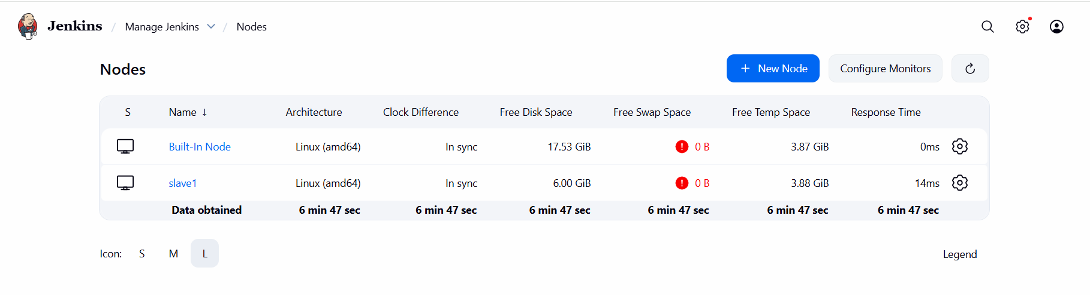
CONFIGURE SLAVE NODE
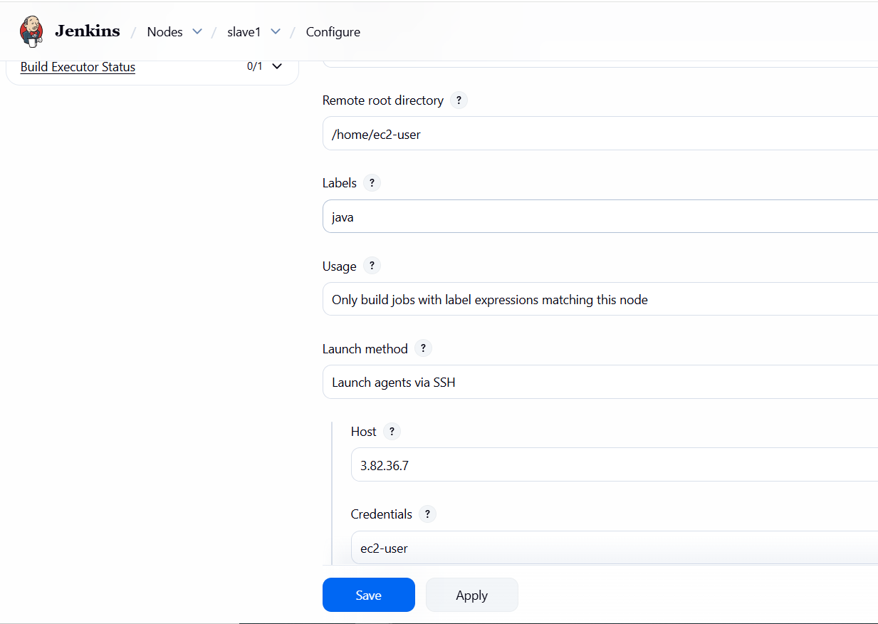
JOBS Running on Master and Slave1

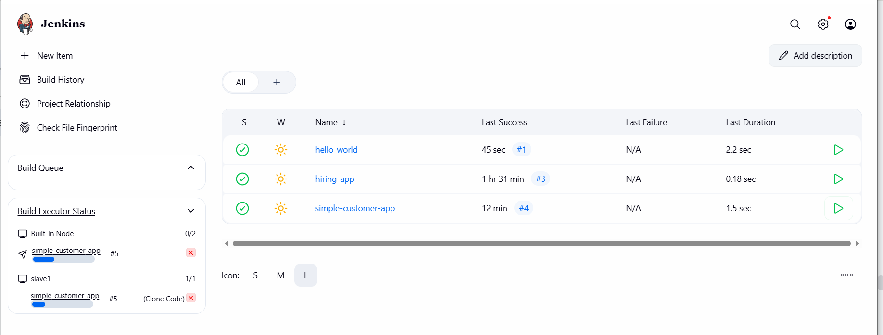
On Slave EC2 workspace , after build files are created.
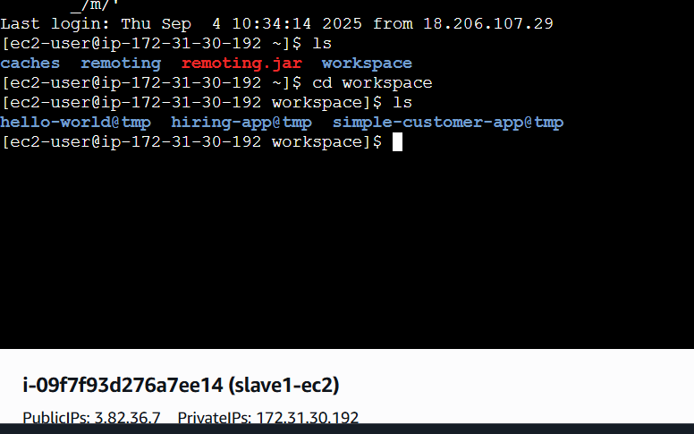
BUILD STATUS OF DIFFERENT JOBS

